CS314 Operating System
Spring 2024
Exercise Questions on April 9th, 2024

EXERCISE #1:

If your PC is stuck when you see the following screen, where did the problem happen (select one from the following options)?

When your PC is using:

- BIOS ROM

- The boot-strap loader in MBR

- The partition table in MBR

- IPL (the OS loader)

- Somewhere not in the above

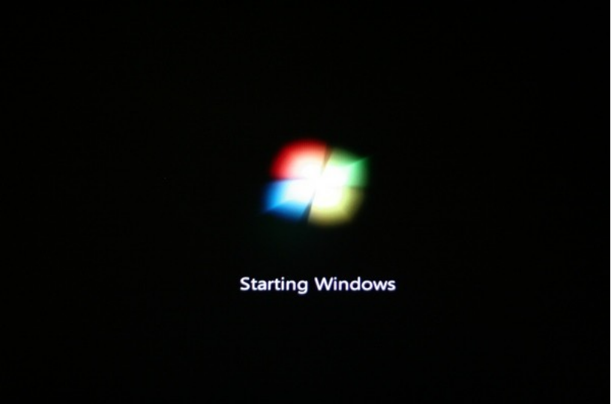
EXERCISE #2:

If your PC is stuck when you see the following screen, where did the problem happen (select one from the following options)?

When your PC is using:

- BIOS ROM

- The boot-strap loader in MBR

- The partition table in MBR

- IPL (the OS loader)

- The target OS

- Somewhere not in the above

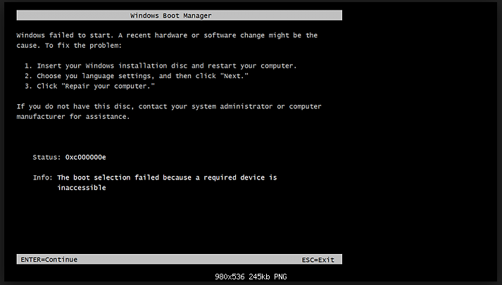

EXERCISE #3:

If your PC is stuck when you see the following screen, where did the problem happen (select one from the following options)?

When your PC is using:

- BIOS ROM

- The boot-strap loader in MBR

- The partition table in MBR

- IPL (the OS loader)

- The target OS

- Somewhere not in the above

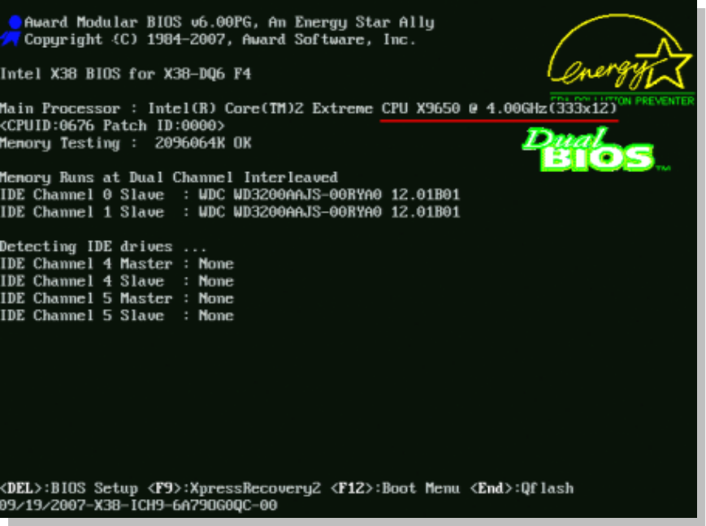

EXERCISE #4:

If the IPL (only the contents of the IPL, but nothing else) of an operating system you installed to your computer system is damaged (the contents in the IPL are screwed up), what information you most probably lose?

Assume that location of the IPL in a partition (it’s always at the beginning of a partition) and size of the IPL is constant (will never change) no matter when and how you install the OS).

- Users’ accounts in the OS
- Users’ files
- OS configurations (desktop images, and other settings each user in a computer system have set up before the problem happens).
- None of the above

EXERCISE #5:

What should you do if:

- BIOS (boot) ROM is damaged?
- MBR is damaged?
- IPL is damaged?

Use the same assumptions you used for EXERCISE #4 above.
EXERCISE #6:

The following is a snapshot of “multi-boot” disk utility tool. Where should such a “multi-boot tool” be installed?

- BIOS ROM
- The boot-strap loader in MBR
- The partition table in MBR
- IPL (the OS loader)
- The target OS
- Somewhere not in the above

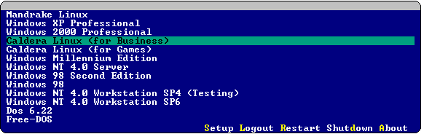

____________________________________________________________________________
CS314 – Operating Systems, Spring 2024, Exercises on April 9th, 2024

