Chemistry Learning In Progress

Design Specifications Document

Nathan Mikeska
Neil Alfredson
Richard Carney
Brian Navarro

Table of Contents

- Introduction 3
1.1 Purpose of the System 3
1.2 Design Goals 3
1.2.1 Dependability Criteria 3
1.2.2 Performance Criteria 3
1.2.3 Maintenance Criteria 4
1.2.4 End-user Criteria 4
1.2.5 Design Criteria 4
1.2.6 Lifecycle 5
1.3 Definitions, acronyms, and abbreviations 5
1.4 Research Topics 5
1.5 Web Page 7
1.6 References 8
- Proposed System 8
2.1 System Overview 8
  - System Decomposition 9
2.3 Hardware/Software Mapping 11
2.4 Persistent Data Management 12
2.5 Access and Control Security 13
2.6 Global Software Control 13
2.7 Boundary Conditions 13
- User Interface 13
- Subsystem Interfaces 19
- Packages and File Organization 20
- Class Diagram 21
- Testing 21
- Glossary 23

1. Introduction

1.1 Purpose of the System
This project can be a learning tool for students and it can also be a
research tool used by professors. The card sorting activities are
designed to give students a better understanding of the periodic table
and how it is organized. It focuses on users finding and understanding
the relationships between many attributes and how to organize
patterns based around these relationships. This system could
potentially be used in assignments for chemistry students. The user
(such as a student) can save their results after using the application.
Another user (such as a professor) can load up a user’s saved results at
a later date. This accomplishes two things: You can view a user’s end
solution and how they moved the cards to arrive at that solution.
Provides observational data that can support the examination of a
user’s thought process.

1.2 Design Goals
The primary design goals of this system are:

1.2.1 Dependability criteria:
Reliability – The system must accurately handle and display
information to the end user either teacher or student

Security – The system must be secured against unauthorized
users modifying a user’s local hard drive.

Robustness – The system must be able to withstand the strain of
a certain size of users at peak times with out crashing or
producing errors. It must be able to withstand invalid user inputs.

Availability – The system should be accessible to students and
the teacher. It may also be used by other teachers and possible
common non-related users.

Fault tolerance – The system must be able to detect erroneous
data and call attention to the user.

1.2.2 Performance criteria:
Response time – The system should respond to user queries and
requests in a timely manner, without long delays regardless of
internet connection.

Memory – The system should appropriately manage its memory
usage to optimize speed and performance and to prevent
memory leaks.

1.2.3 Maintenance criteria:
Modifiability – The system needs to be designed and
implemented in an efficient object oriented manner in
anticipation of any interface or functional application updates to
the system including loading new tile sets.

Readability – The system layout, design, and code needs to be
easy to navigate and understandable by any developer who
would later be modifying the code or adding additional features.
This can be accomplished by utilizing clear coding standards and
module descriptions.

1.2.4 End User criteria:
Usability – The system should be usable to a wide range of users
from novice to expert, and should be clear enough to intuitively
define what is required by the user and what the user is supposed
to do, and what the user is allowed to use.

1.2.5 Design Tradeoffs
Designers have to make several tradeoffs over the course of a
project, some of them include space vs. speed, delivery time vs.
functionality, and using databases vs. files. The first tradeoff
involves space vs. speed, if the response time or throughput of
the software does not meet requirements, more memory can be
used to speed up the software. If the software does not meet
memory space constraints the data could be compressed to
save space at the cost of speed. The next decision that has to be
made is delivery time vs. functionality. If time runs
short, less functionality can be delivered on time or full
functionality can be delivered at a later date. The team will satisfy
the functional requirements as stated in the Requirements
Analysis Document. Any other additional non-major functionality
will be sacrificed due to the fixed delivery time of the system.

The final tradeoff is whether to use a database vs. file for storage.
The latter is good for storing large files such as images or for
storing temporary files, but it would not be scalable to multiple
users. A database, on the other hand, can provide access to
multiple platforms and allows concurrent users.

1.2.6 Lifecycle Model
The lifecycle model that we will use for the entirety of project will
be the waterfall model. However, within our coding and testing
phases, we will gear our model to a more evolutionary
prototyping approach.

Given the small team size and project milestone deadlines, the
waterfall model provides a solid lifecycle that we can follow
without needing to make compromises to our goals or deadlines.
During the coding and testing phases of the lifecycle, our project
will take an evolutionary prototyping approach. It is very
important that the system be easily understood and used by the
users. This will require a strong focus on providing a good user
interface for users to interact with the system.

Therefore, the evolutionary prototyping will allow us to gather
important feedback on each iteration of the prototype so that we
may provide the best possible interface for the users.

1.3 Definitions, acronyms, abbreviations
Tile set - a group of related image files that contain the information for
a student to organize.

Tile - This is the digital equivalent to the paper card in the current
system. However, when in the play area it will be referred to as a card.
Therefore, both terms (card and tile) refer to the same object, but only
differ in referencing terms based on their location.

1.4 Research Topics
Java Applets
In order to accommodate for our client’s web-based requirement, we
have been researching the use of Java Applets. Java Applets are Java
written applications that are accessed via the internet through a java-
enabled web browser such as Internet Explorer or Mozilla Firefox.
Our research has raised a concern with reading/writing of files. This
is more explained in Web Security Issue section. Furthermore, the
other limitations of applets must still be explored.

Web Security Issue
Due to the nature of Java Applets being web-based, they raise a few
security issues relating to the reading and writing of files to a local
computer. By default Applets are not allowed to alter a computer’s
files due to built-in security manager within the Java language. The
work-around to this is to sign the applet with a ceritificate indicating it
is safe to allow this program to read/write. Signing an applet can be
done with a Microsoft Sign Tool, by purchasing a certificate from
Verisign, or unofficially sign the applet with the included Java sign-tool
where you create your own certificate with name, organization,
location, and password indicating that the applet is safe to allow
read/write. This is something to be discussed with our client still.

Input/Output File Format
The necessary information that must be in each of the files we intend
to use still needs to be researched.

Tiles Sizes
Currently we do not know the dimensions we need for our tiles. This
issue needs to be discussed with our client to determine if varying tile
sizes is what she will want as some sets require different amounts of
information.

Patterns
Patterns are defined solutions that will be used to match user’s solution
against to check for correctness. This is currently not fully understood
and defined so it is still being researched and explored. Therefore, the
option of the Pattern Editor now shown in the User Interface may be
removed at a later date if it is discovered that we can not accomplish it.
It is not a required feature, but would be useful to incorporate.

Grid Size
The Grid size is unknown at the moment, partly due to the fact that tile
sizes are not known either. In addition, the maximum amount of
cards that a set would ever have and how big each card in that set
would be affect how big the grid needs to be. Furthermore, whether or
not scrolling will be allowed deeply affects the size since we are dealing
with limited space so this issue needs to be researched and resolved.

Mini-map
Due to the fact that the grid size requirement (which is not known yet)
by our client may be too large to show on the screen all at once, we
will have to use scrolling. In order to deal with this, we are currently
researching the idea of using a mini-map which will show a miniature
version of the entire grid and the locations of each tile. Whether or not
this is possible given time and experience constraints is what must be
researched.

Programming Language
Our Requirements Analysis document has led to potentially choose the
Java language since it is well-known for allowing the creation of web-
based applications, though the language when used to create applets,
tend to create simple and small applications. More research must be
done in this area to assess the viability of using Java to accomplish all
we need through a web-based application.

Development Tools
Our development tools thus far have included Microsoft Word/Paint
for User Interface Design, Microsoft Visio for Diagram Design, and
Macromedia Dreamweaver for Website Development. In the future,
we will be using most likely JBuilder 10 Foundation Edition for our
hi-fi prototype and finished product, and SmartFTP for uploading the
applet and the corresponding web-page to a web-server.

1.5 Web page
A web page will be necessary in order to host the web-based
application. In addition, the web-page will have tutorials on using the
application and customizing it.

Web-accessed ‘How-To’ Tutorial
On the same page as the web-based application, a tutorial explaining
how to use the various features will be provided. It will go through
loading sets, creating/modifying sets, loading a recording, saving a
recording, and a step by step to arranging tiles to create a solution.

Web-accessed Application Setup Tutorial
Available also on the page of the web-based application will be some
basic step by step for customizing the application.

Web page Setup
The web page will consist of three components: the web-based
application, the ‘how-to’ tutorial, and the application setup tutorial.

1.6 References
Read/Write with Applets
http://www.captain.at/programming/java/

Signing an Applet
http://www.codeproject.com/useritems/Singed_Applet.asp
http://java.sun.com/j2se/1.4.2/docs/guide/plugin/developer_guide/

Our Website
http://www.cs.siue.edu/SeniorProjects/f05g6/

2. Proposed System Architecture
2.1 System Overview

Complete System
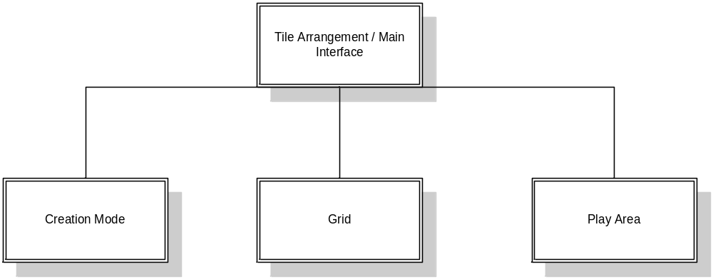

Tile Arrangement System
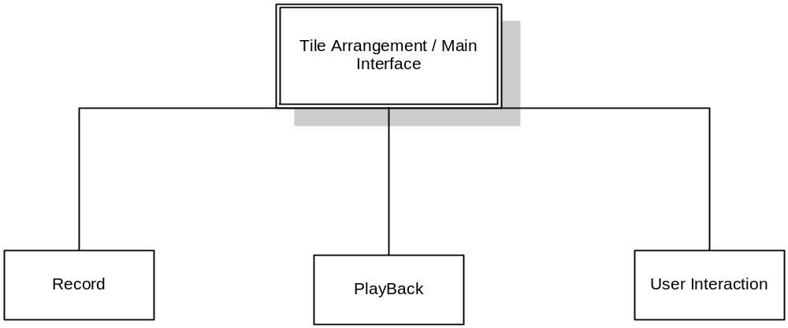

Creation Mode System

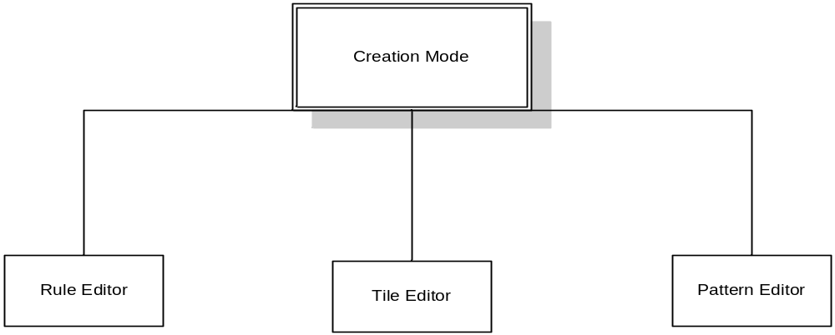

2.2 System Decomposition
The system is divided into four main subsystems. The Grid and
PlayArea are the two subsystems that make up the main interface of
the program and interact with the user. The Creation subsystem is
responsible for the creation and modification of tile sets. The Tile
Arrangement / Main Interface subsystem is the subsystem that ties
together the rest as well as handles communication between most
parts of the program.

Breaking down the system into these smaller subsystems and modules
serves a couple purposes. First of all, it provides a good layout for the
architecture of the system. It makes the system easier to understand
and allows for tackling one problem at time. Second, it allows for
team members working in parallel on different parts of the system at
the same time. The biggest goal in the subsystem decomposition is to
minimize the coupling between modules and maximize the cohesion
within modules. This makes the system easier to understand and
implement.

The Grid
The Grid is a grid where the arrangement and display of tiles is done.
The grid works through drag-and-drop event driven interaction with
the user.

The PlayArea
The PlayArea is located to the right of the grid and is where tiles are
located when not currently placed on the grid. Tiles within the
PlayArea may be sorted by the user if they wish by the drag-and-drop
method.

Tile Arrangement / Main Interface
This subsystem is one of the most important subsystems in the
system. This is the module that ties together the other subsystems
and handles communication between the subsystems. Within this
subsystem exist the Record, Playback, and User Interaction modules.

Record
This module is the module that governs the arrangement and
recording of tiles. This module handles what has been referred to as
the Tile Arrangement Mode. Its main function is to record the user’s
movement of tiles on the Grid and PlayArea.

Playback
This module is what handles Playback Mode. Its purpose is to read
information from log files and allow the user to view the moves
recorded in the log file. This subsystem allows the user to skip
forward and backwards through the list of the user’s moves. It also
allows for automatic playback of the user’s moves.

User Interaction
This subsystem is the module of the Tile Arrangement / Main
Interface subsystem that handles all the user interaction. This mainly
consists of handling mouse clicks and dragging and sending the
necessary information back to the Tile Arrangement / Main Interface
module.

Creation Mode
This is the subsystem that handles the creation and modification of tile
sets. It includes and ties together the functionality of the Tile Editor,
Rule Editor, and Pattern Editor modules.

Tile Editor The Tile Editor is what handles the addition, deletion, and
modification of tiles within a set.

Rule Editor
The Rule Editor is responsible for the modification of each tile set’s
rules. It allows the user to modify rules and then the module writes
these rules to the tile set’s rule file.

Pattern Editor
The Pattern Editor handles the addition and deletion of patterns from
tile sets. It uses the functionality of the Grid to arrange the tiles into
patterns.

2.3 Hardware/Software Mapping
The CLIP system is online and requires that the user have a Java
technology-enabled browser. All interfaces for the system will be
stored on the server, with the system’s code being executed by the
browser’s Java Virtual Machine. The system will have access to the
hard drive of the user’s PC so that two files may be stored in
secondary memory.
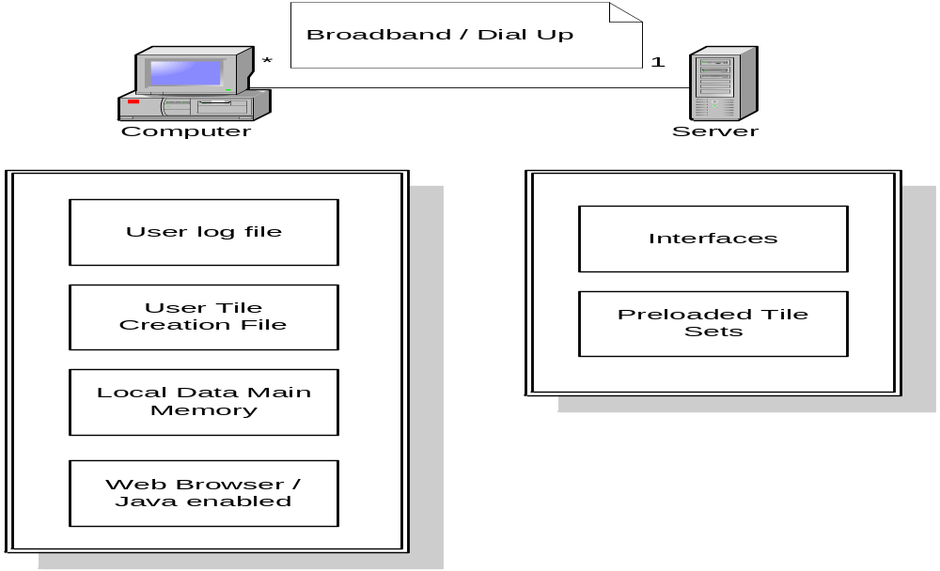

2.4 Persistent Data Management
The system will handle persistent data through the use of a flat file.
When the user performs a drag drop operation the tile id, original
location, new location, and system time of the tile’s movement will be
stored in main memory on the PC.

When the user selects submit arrangement the log information in
main memory will be flushed and written onto a text file located on
the PC’s secondary memory.

During playback mode the information from this text file will be
loaded into the main memory of the PC. From there it can be
accessed and the user’s movements can be sequentially viewed.

Another file will be created upon the user entering creation mode.
This file will contain the information about the user’s created tile set.
This information will include the number of attributes an individual
tile has, the number of tiles included in the set, the values of the
attributes for each individual tile, the id of each individual tile, and the
acceptable patterns associated with the arrangement of the grid for the
tile set. This file will be stored on the secondary memory of the PC.

When the user uses the system the information from this file will
be loaded into main memory and the user tile set will be included
among the preloaded tile sets. The preloaded tile sets will be stored
similarly but on the server not the users PC.

2.5 Access Control and Security
CLIP is an online system that is accessible to anyone with an internet
connection and browser. There will be no restriction on the systems
functionality regardless of the user. Security is only necessary on the
side of the server where preloaded card sets will be added to the
system by an authorized instructor.

2.6 Global Software Control
The system is event driven. The actions taken by the users either
by dragging/dropping a tile, pressing a command button, or selecting
menu option, will determine which sub system is activated. If there is
no action taken by the user then system is idle.

2.7 Boundary Conditions
Initialization
The system will be a java applet. It will be available to the user
through the web-browser at a location of our client’s choice. It will
allow the user to save their work as individual files to their own
computer and also allow users to view the playback given a saved file.

Termination
The system will be shut down by exiting the web-browser.

Failure
After an unexpected failure, the system will display a brief, descriptive
error message to the user before termination. The system will not
create any sort of backups to the data within the system.

3. User Interface
Introduction
The User Interface of the C.L.I.P web-based application is at the center of
the transformation from the current system to the proposed system. This
is because the interaction of the current system is physically carried out and
therefore must feel the same way in the proposed system. The way we are
accomplishing this is through a visual environment that represents the
components of the physical environment and still allows for the same easy
interaction with the new environment. The remaining areas of the User
Interface section will explain what they are meant to accomplish.

Menu System – Setup

File Menu – Loading/Saving a User End Solution
- Load Recording
- Save Recording
- Load Card Set

Edit Menu – Card Sets can be created, loaded, and modified.
- Create Set

Tools Menu – Options relating to the customizing the application to your preference.
- Application Options (Undecided)
- Other Options (Undecided)

Window Menu – Undecided
- ?

Help Menu – Information on tutorials and about the application.
- ‘How To’ Tutorial (Web-accessed)
- Application Setup (Web-accessed)
- About

Startup Screen
The startup screen appears with just The Grid and an empty window
that represents the play area. This window will have several components
like an area for the list of tiles, the recording-playback features, check-
pattern button and new-card tile button. More info on the play area can
be found in the next section. The user will start using the web-
based application by clicking under the file menu – load card set, which will
allow the user to choose an existing card set and load it into the play area so
they can be begin their task. This leads us into discussing the play area.

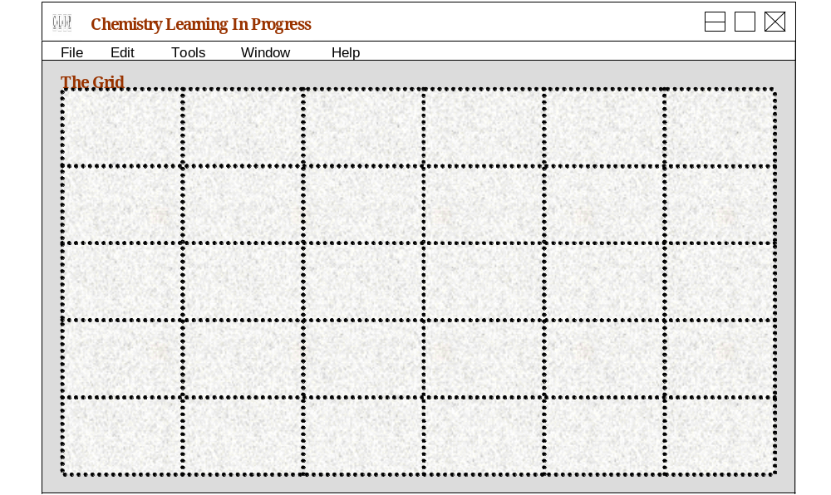

Play Area Windows – Possible Versions
There exist different versions of the Play Area windows due to several
existing User Interface design impasses. However, there are some basic
things that all play areas no matter what design is chosen need to
accomplish. These include: providing a reasonable sized area to list and
display the tiles and their information, record-playback components, a new
card button, and a check pattern button. The complete design of the Play
Area is unknown at this moment due to User Interface problems that have
arisen. More information on this is discussed in the Research Topics area
(ie: Grid Size, Tile Size, Mini-Map, etc..
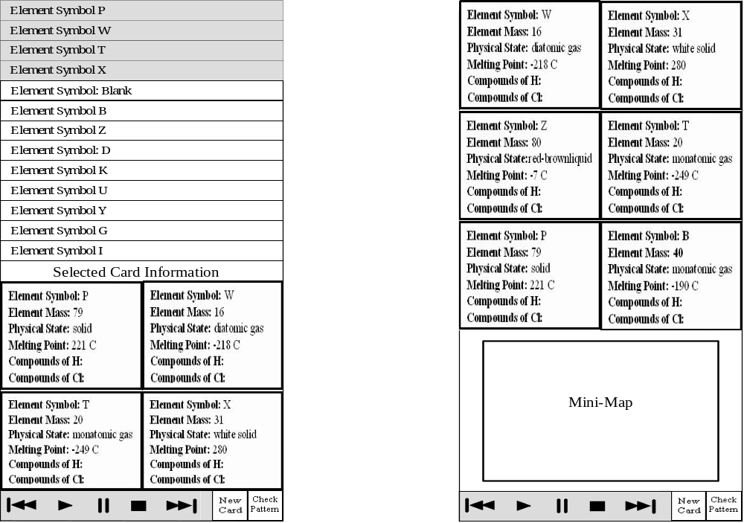

File Menu Design Actions
The file menu contains our some commands that accomplish a large part of
our intended functionality. This includes Loading a recording, Saving a
recording, and Loading a card set into the Play Area.

The first command, Load Recording, allows for a user to load and play
another user’s solution from beginning to end where at the end the final
solution is presented, including what tiles were not used.

The second command, Save Recording, allows for the current user to save
their final solution, including any tiles they leave in the play area.

The final command, Load Card Set, allows for the current user to load the
tile set that they wish to arrange. When the user selects this option, it turns
on the recording option, waiting for the first movement of a tile before it
starts recording.

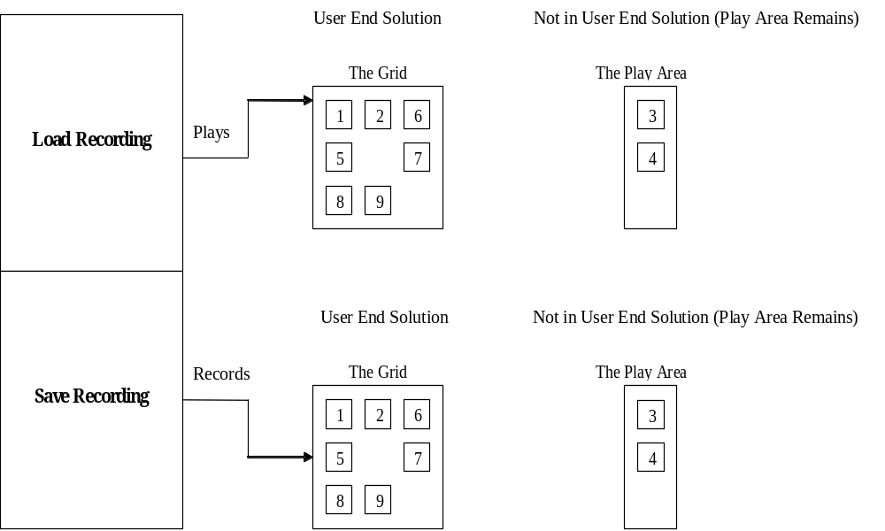

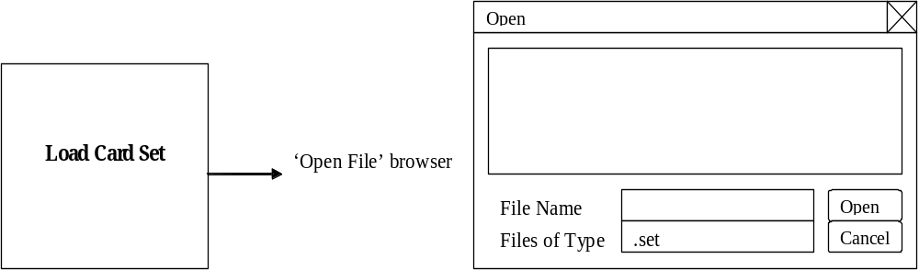

Edit Menu Design Action
The Edit Menu lists a single command called Create Set. This will be
responsible for showing the user all the possible choices for working with a
set including creating/modifying the rules for a set (ie: name, desc, and
other options), creating/modifying the cards for a set, and finally
creating/modifying the patterns (best possible solutions) that are a part of
the set. Currently the Card Set Editor is the only option designed. The
others require research to be done for their particular capabilities.

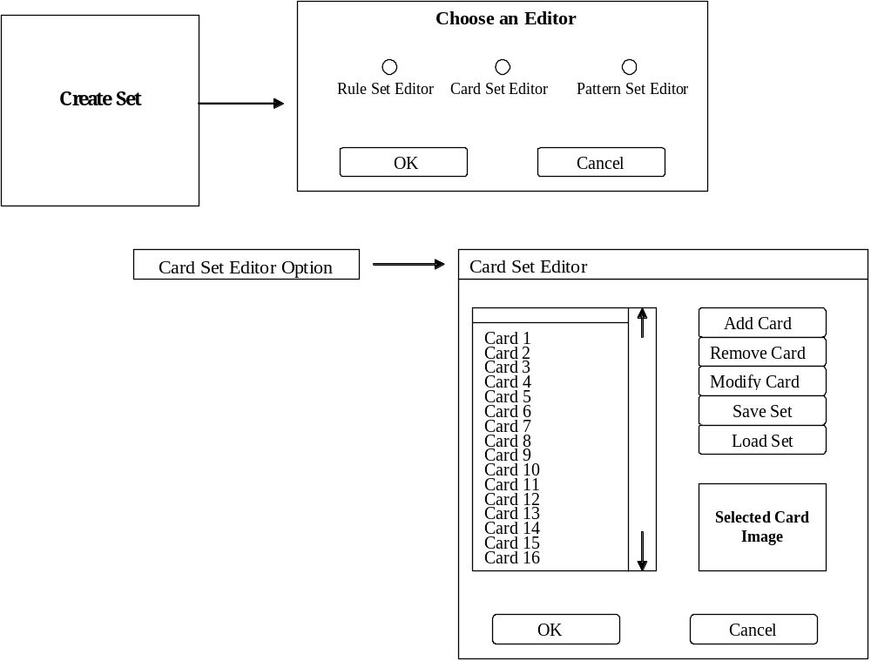

Tools Menu Design Action
It is unknown what options we will provide to the user to customize the
application to their preferences. Those are being researched.
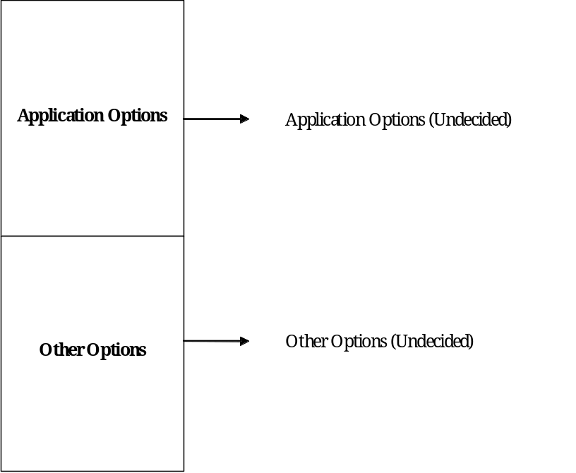

Help Menu Design Action
The Help menu has 3 options. The first two deal with providing
information on where to look for information on using the application and
customizing the application, respectively. The actual information on this
will be provided on the website where the applet is hosted. The last
option provides information on the designers of C.L.I.P. project.

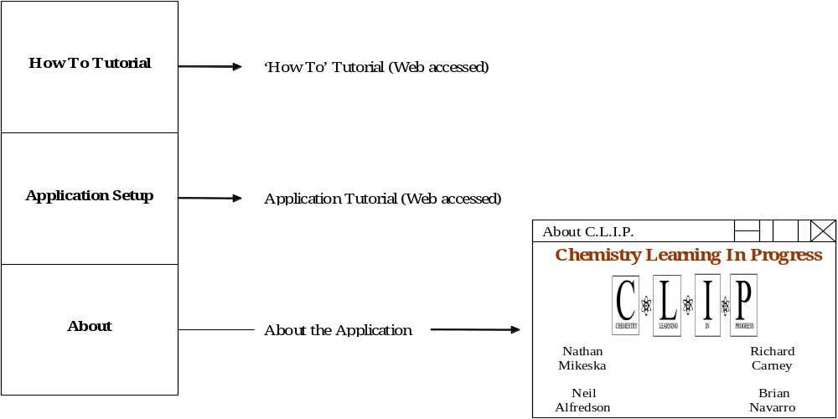

4. Subsystem Interfaces
The Grid
The Grid communicates with the Tile Arrangement / Main Interface
subsystem. That interface then handles communication between the Grid
and the other modules. The communications will mainly consist of grid
coordinates and tile IDs passed back and forth between the Grid subsystem
and the Tile Arrangement / Main Interface subsystem.

The PlayArea
The PlayArea communicates with the Tile Arrangement / Main Interface
subsystem. That interface then handles communication between the
PlayArea and the other modules. The communications will mainly consist
of tile IDs passed to and from the Tile Arrangement / Main Interface
subsystem.

Creation Mode
This subsystem does little communication with the Tile Arrangement /
Main Interface subsystem except passing information between that module
and the Pattern Editor.

Tile Arrangement / Main Interface
This subsystem handles all communication between the Grid, PlayArea,
and the other subsystems. Its communication lines are explained more
thoroughly in the descriptions of the other modules that communicate with
it.

Record
This module only communicates with the Tile Arrangement / Main
Interface module. It receives information stored in memory about user
moves and then writes that information to a file.

Playback
This module reads in information concerning user moves and stores them
in memory. It then passes this information to the Tile Arrangement / Main
Interface subsystem.

User Interaction
This module handles communication between the user and the rest of the
system. It receives input from the user via keyboard or mouse and passes
this information to the Tile Arrangement / Main Interface module.

Tile Editor
The Creation Mode subsystem passes the set and tile information of the
currently loaded set to this module. That information is then passed back
when this module closes.

Rule Editor
The Creation Mode subsystem passes the set information of the currently
loaded set to this module. That information is then passed back when this
module closes.

Pattern Editor
The Pattern Editor relies on the Grid so grid coordinates get passed to and
from this module going through the Creation Mode subsystem. The
Creation Mode subsystem also passes the set and tile information of the
currently loaded set to this module. That information is then passed back
when this module closes.

5. Packages and File Organization
Tile Files
The tile files are sets of picture files that are to be loaded by a user to be arranged on the grid. The system will begin with several different sets of tiles for use by the users. To allow the expansion of the program the system can have additional tile sets created.

Example of Tile set:
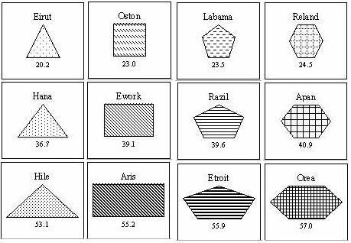

Input/Output Files
This project will require the use of input and output files in order for the playback functionality to work properly. When a user of the system loads a set of tiles we will begin recording all of the moves that he/she makes. The system will record each time that a user drags a card from its current location and record where the user sets down the card. The program will place all of this information into a file when the user saves. The program can use this file in order to playback every move that was made during the organization of a certain set of cards.

6. Class Diagram
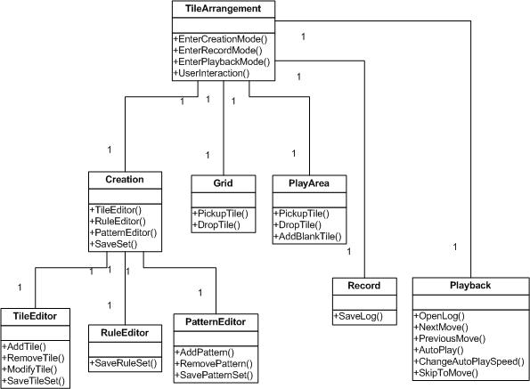

7. Testing
Testing will consist of four parts: Module testing, Integration testing,
System testing, and Acceptance testing.

Module Testing
The behavior of each module in our system will be tested once it has been
completed. This will be repeated until each module in our system acts as
intended. Outputs will be examined after a set of test input has been
entered. Each module will be tested both with expected and boundary
inputs to ensure that it behaves properly up to established limits. This will
allow us to guarantee that each module works properly within the limits
that we have set.

Integration Testing
After the completion of module testing, each component will be tested for
compatibility with established system sections. Stubs and drivers will be
used to imitate any sections that have not yet been completed.

System Testing
Following the completion of each delivery cycle each system will be tested
to ensure that it performs as intended. Usability testing will also be
performed at the end of each delivery cycle to ascertain the system’s ease of
use and determine possible changes for its improvement. Usability will
probably be the most important aspect of the testing, because making sure
that the students and professors like our program will determine if it gets
used. Interaction tests will be performed with the systems to determine that
all functions are operating correctly. Sample systems will be designed in
advance to test expected and boundary functionality of the system.

Acceptance Testing
Throughout the development of the project, we will from time to time
show our client Professor Susan Wiediger portions of what we have created
to ensure that our design meets his needs. We will also develop
screenshots of what our interface will look like to make sure it is acceptable
before we finish designing it. This will give us the ability to make any
changes to the system Professor Wiediger sees fit during development. If a
portion of the system is not working to her approval, it will be redone until
it meets her standards. We have already shown and had approval of some
of the aspects of our system due to screenshots of the grid and play area.

Prototype Testing
Our team will develop prototypes

Low-Fi
Our group will develop a lo-fi prototype in order to show it to our client and for usability testing. This will likely be screen mockups and paper implementation. This will allow us to determine if certain aspects of our intended user interface will be understood by the users. We will nee to let both the professor and a number of students to use the prototype. This will help us be reasonably sure that all of the intended users will be able to understand and use the software we are developing

Hi-Fi
We will also develop a more high-end prototype to help us test the functionality of the program. This will be developed using a high-level language and be very similar to the end product. We will use this prototype to smooth out only relatively simple details. The team will also use students and the professor to make sure that everything works as intended and is a viable end product. This prototype will be developed only after the lo-fi prototype has and finalized and we are sure that are general design is easy to use and understand.

8. Glossary
Version # | Date | Author | Description
0.1 | 10/05/05 | Brian Navarro | User Interface Design, Research Topics
 | 10/06/05 | Neil Alfredson | Purpose of the System, Design Goals (Except for Lifecycle model), Boundary Conditions, Packages and File Organization
 | 10/07/05 | Nathan Mikeska | Lifecycle model, System Decomposition, and System Overview
0.2 | 10/08/05 | Richard Carney | Global Software Control, Access Control and Security, Persistent Data Management, Hardware/Software Mapping. Revised the System Overview.
 | 10/08/05 | Brian Navarro | More User Interface Design, Web Page Content Description, and Research Topics.
 | 10/08/05 | Nathan Mikeska | System Decomposition (Revised), Subsystem Interfaces, Class Diagrams.
 | 10/08/05 | Neil Alfredson | Testing
0.3 | 10/09/05 | Brian Navarro | Design Specification Document Formatting, References
0.4 | 10/09/05 | Nathan Mikeska | Class Diagram
1.0 | 10/09/05 | All Members | Minor grammer and spelling fixes. Reviewed by team and accepted as version 1.0

