

Retrospective on
Project Plan and System Design

Client: Steve Klein
Southern Illinois University Edwardsville

Group Members:

Aaron O’Banion
Todd Astroth
Mark Williams
Chris Cobb
Matt Stowe

Table of Contents

1.) Aspects Carried Out According to Plan 3
1.1) User Interface 3
1.2) Persistent Data Management 3
1.3) Subsystem Decomposition 3
1.4) Hardware / Software Mapping 4
1.5) Risks Dealt With According to Plan 4
2.) Aspects Carried Out Differently from Plan 5
2.1) Lifecycle Model 5
2.2) Timeline 7
2.3) Testing 9
2.4) Team Training 11
2.5) Risks Dealt With Differently from Plan 11
3.) Contributions 12

List of Figures

Figure 1.3 – Subsystems in Quoridor 3
Figure 1.4 – Clients connecting to the Server 4
Figure 2.1.1 – The Quoridor Model 5
Figure 2.1.2 – The Sashimi Model 6
Figure 2.2.1a – CS 425 Timeline 7
Figure 2.2.1b – CS 499 Timeline 8
Figure 2.3.2 – Script used to Debug Networking Version 10

1.) Aspects Carried Out According to Plan

1.1) User Interface

Our program used three basic screens from the start of the semester: a Splash title screen, a player setup screen (Host and Client), and a game board. From the HCI testing, the students never had any difficulties with the setup screen, meaning it was well-designed from the beginning. The game board has undergone a few interface changes, but underneath the makeover is still the original game board.

1.2) Persistent Data Management

Much of Phase 1 was spent adding the functionality to save games and continue them later. With a few exceptions dealing with networking, this functionality was added at the planned time and still works as intended.
Although this functionality was a success, it probably would have been best to add this after adding AI’s and Networking. The reason we added this in Phase 1 was because it was higher on our client’s list of priorities than networking or AI’s.

1.3) Subsystem Decomposition

Quoridor was broken down into the subsystems shown in Figure 1.3.
Interface
Client
Game
Remote
Server
Host
Game
Game
Client
Interface
Client
Client
Client

Figure 1.3 – Subsystems in Quoridor

We divided the project into five separate subsystems: Game, Interface, Client, Server, and AI. With only minor changes to the mapping during CS 499, this combination has been a fairly solid and consistent representation of the project.

1.4) Hardware / Software Mapping

As the diagram in Figure 1.4 indicates, this is the basic linkage we used in Networking. One Host instance controls the game, and up to three Client instances of the game communicate with the Host.

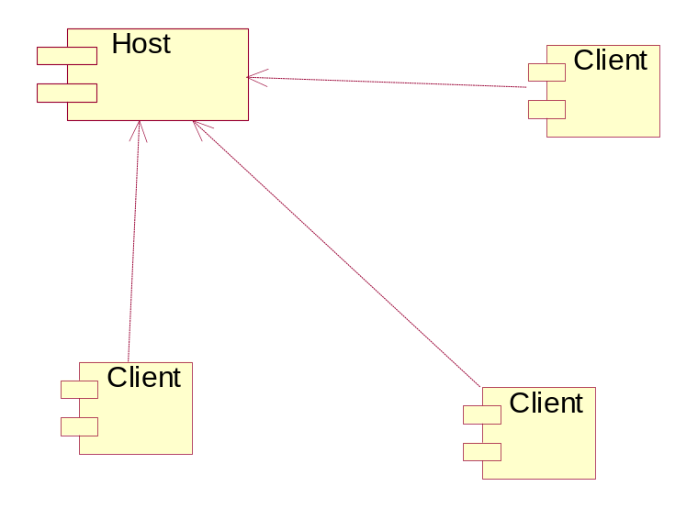

Figure 1.4 – Clients connecting to the Server

1.5) Risks Dealt With According to Plan

1.5.1 Team Conflicts

Our group is very diverse. We all have our own design ideas and styles of coding. Plus, having five people on the team talking at once can be very stressful. Sometimes situations would get out of control when members would disagree. However, the team leader followed through with our plan, and any major incidents were reported to Upper Management.

1.5.2 AI Functionality

We foresaw that there could be issues with the AI functionality. We predicted that our lack of knowledge of AI modules could set the project back. However, we followed through with our plan, and we spent extra time before Phase 3 learning about and planning AI’s.

2.) Aspects Carried Out Differently from Plan

2.1) Lifecycle Model

2.1.1 Original Plan

We originally developed the Quoridor Model (Figure 2.1.1). During the “Requirements Analysis” phase of the project, one part of our team works on gathering requirements while the other begins the design phase. While parts of the team work on the Design Document, other team members begin working on their parts of the prototype. This part of the lifecycle is similar to the Sashimi model. When the design is all finished, the team codes in a manner similar to the “Waterfall with Subprojects” model. Team members are in charge of different subprojects, and each aspect is to be developed in parallel. This continues throughout three phases. In the first phase, we complete all functionality required to play a complete hotseat game. In the second phase, we add all networking functionality to be able to play on multiple computers. And finally, in the last phase, we add AI functionality so that AI modules may be inserted.

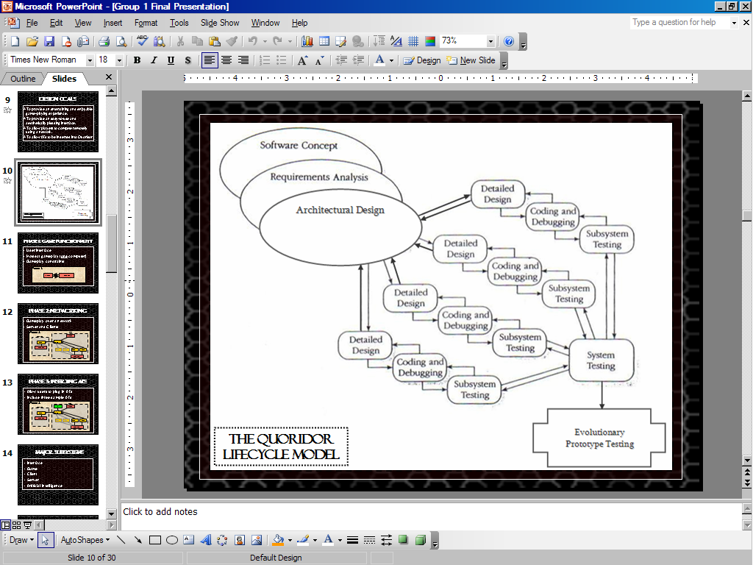

Figure 2.1.1 – The Quoridor Model

2.1.2 Actual Implementation

The first half of our project (CS 425) was the same as the Quoridor Model. This is because it was borrowed directly from the Sashimi Model. However, for the second semester, we actually followed the full Sashimi Model below in Figure 1.3.

First, understanding the basics of the game and the project are done in the “Software Concept” phase. During the “Requirements Analysis” phase of the project, one part of our team worked on gathering requirements while the other part began the “Architectural Design” phase. While parts of the team worked on the Design Document (beginning the “Detailed Design” phase), other team members began the coding phase by working on their parts of the prototype. The coding and testing occurred throughout our three phases. In the first phase, we completed all functionality required to play a complete Hotseat game (“complete” as determined by our client’s requirements). In the second phase, we added all networking functionality to be able to play on multiple computers. And finally, in the last phase, we added basic AI functionality so that AI modules may be inserted.
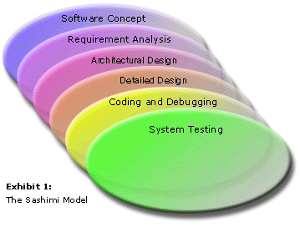

Figure 2.1.2 – The Sashimi Model

2.1.3 Alternative Plan

Even though we did not use the Quoridor Model we developed in CS 425, we felt that the Sashimi Model really drew the big picture for the whole project. At the time, we had doubts about the Quoridor Model. We originally planned to do the three phases simultaneously, which we did do to an extent. But, the main coding and testing of each phase took place sequentially. Therefore, we feel that the Sashimi Model is the best choice for this project.

2.2) Timeline

2.2.1 Actual Implementation

The timelines have been tweaked from time to time throughout the semester, but in general, the pattern follows the original plan.

Figure 2.2.1a shows the timeline for CS 425. Creating and designing the Prototype was the main goal of the first semester. At the time, we were not concerned about code modularity – just as long as we had a working prototype and a plan for the next semester.

Figure 2.2.1b shows the basic timeline for the CS 499. We divided the implementation of the system into three phases. In Phase 1, we added gameplay constraint checking (i.e. No jumping over walls, no double-jumping over tokens, etc.) and other non-networking, non-AI functionalities such as saving a game. However, this took longer than expected. Discussion of rewriting the existing code to make it modular occurred, but it was decided that writing new code would take too long. In Phase 2, we added the ability to network. This proved much more challenging than originally thought because the existing code was not modular. Plus, there were several issues with data flow and game constraints. The game was so complex that finding every detail needed to pass information between computers became a complicated task to code. Phase 3 started almost a month behind due to the complexity of networking. Luckily, the AI plan was deemed to be easier than we originally thought, and the basic plans for the Phase were ready. But, another problem came up when we found out that C++ and Visual Basic sockets are incompatible. This meant that the AI module code had to be rewritten in VB.
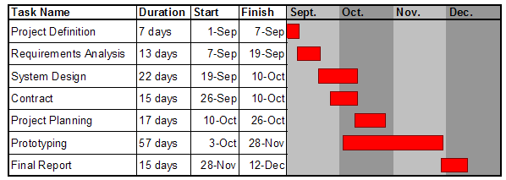

Figure 2.2.1a – CS 425 Timeline

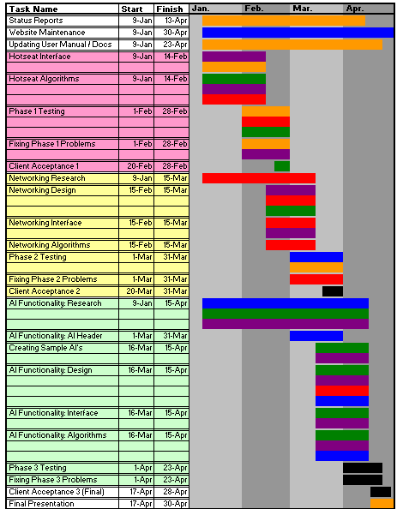

Phase 1
(Hotseat)

Phase 2
(Networking)

Phase 3
(AI)

Figure 2.2.1b – CS 499 Timeline
(Green = Aaron, Blue = Chris, Red = Mark, Purple = Matt, Orange = Todd, Black = All members)
2.2.2 Alternative Plan

First, more time should have been spent on designing the system and less on project planning. Dr. Waxman should have done the Project Plan sooner. Also, the group should have worked together to code an efficient, modular, clean prototype in CS 425. The emphasis would not be on features, but on getting the foundations of the basic game code laid. Having knowledge ahead of time about AI modules and networking would have helped.

Phase 1 of CS 499 would be a short period where any required constraints of the game would be finished. Then Phase 2 would be an extra-long phase where the team works on networking and AI modules in synch. That way, the data flow can be declared up front as each aspect is coded. Any additional features would be left for an optional Phase 3 if there is time remaining.

2.3) Testing

2.3.1 Original Plan

The original testing plan included five formal types of testing: Module Test, Module Test (Interface subsystem with game validation), Integration Tests for each phase, System Test, and Acceptance Test. For each test, scripts would be written to formally test certain functionality.

2.3.2 Actual Implementation

Formal scripts were not created for every iteration of the project. Rather, some scripts were written when bugs came up while testing networking. These were used to help duplicate the process and debug the program. A sample script we used for debugging networking is shown in Figure 2.3.2.

In addition, we also performed HCI testing with introduction Computer Science students. This was not part of the original plan, but we found this testing to be very beneficial and informative. We gathered some good feedback and ideas regarding the interface from the students. For example, when a player hovers over a highlighted space to move their token to, their token appears in that space as a preview. This was an idea suggested by a student who was not aware that he could move his token. For more details on the HCI test results, see the Testing Specifications Document.

Host | Client
Start up game | Start up game
Click “New Game” | Click “Join a Hosted Game”
 | Type the Host IP and Port #
 | Click “Connect”
Select “Remote/AI Player” for Player 2 and select Client player from dropdown list
Set board size to 6x6
Set wall count to 2
Click “Begin Game”
VB RUNTIME ERROR #1 or #2 on Game Board (System.IndexOutOfRangeException frmMain.vb:line 1509 OR line 1156) | VB RUNTIME ERROR #1 or #2 on Game Board (System.IndexOutOfRangeException frmMain.vb:line 1509 OR line 1156)
Click “Continue.” Game proceeds. | Click “Continue.” Game proceeds.
Place a wall
 | Place a wall
Place a wall
BUG: Two “Out of walls” message boxes come up instead of one
 | Place a wall
 | BUG: Two “Out of walls” message boxes come up instead of one
Move tokens until Host wins
“Game Over” message comes up | “Game Over” message comes up
 | Click “New Game”
 | VB RUNTIME ERROR #3 (System.NullReferenceException frmWinner.vb:line 119)
 | Click “Continue.”
 | Click “Exit Quoridor”
 | Game exits.
Message appears: “One of the players has left the game.”
Click “Exit Quoridor”

Figure 2.3.2 – Script used to Debug Networking Version

2.3.3 Alternative Plan

Although we did not write scripts for every iteration of the project, we still feel that the style of testing we performed in the project was efficient. More scripting would have been nice; but like many Computer Scientists, the team members are generally not “document-savvy.” Plus, with so five members on the team to test the program, there was always time to test informally on a regular basis.

2.4) Team Training

2.4.1 Original Plan

The original plan was to have the group learn how to link subsystems together over a network in order for the system to function as a whole. Also members should know how to implement basic Artificial Intelligence modules so that we can add this functionality to the system later to make this functionality as easy to use for our client and intended audience.

2.4.2 Actual Implementation

Some team members learned AI functionality during Phase 1 and Phase 2 as planned. However, only one member worked heavily on networking. This was not a big issue, however, since the others worked on designing AI functionality. The big issue was the lack of modularity in the prototype.

2.4.3 Alternative Plan

There is no way we could have known what classes we should have taken before Senior Project; but if we would have known, we would all have taken classes in Artificial Intelligence and Networking. Having more experience in these fields would have helped us design the system better in the beginning of CS 425.

2.5) Risks Dealt With Differently from Plan

2.5.1 Backtracking Difficulty

Upon development of certain features, such as the networking and AI issues, we predicted that we may have to backtrack through design. When we foresaw that the prototype code would be troublesome for the upcoming phases, we did not follow our plan to redevelop the design and code. Instead, we tried to work around the code, which proved to be very complicated. We should have gone back and recoded the prototype code to be modular.

2.5.2 Networking Difficulties

We predicted that lack of knowledge of networking in Visual Basic could cause unforeseen difficulties in implementing the network. We originally planned to learn networking before Phase 2 and allocate more time. We did allocate more time for networking, but little effort was given to studying networking.

3.) Contributions

Retrospective:
Todd Astroth

