Pattel
Chemistry Pedagogy Pattern Language Project

Final Documentation



Team Members:

Dan Harrington
Brian Bogovich
Chris Fleenor
Andrew Miles

Table Of Contents

Table of Contents……………………………………………………………………2

Section 1: Overview…………………………………………………………………4

Section 2: Requirements Analysis
Section 2.1: Introduction……………………………………………………..5

Section 2.2: Proposed System………………………………………………..5

Section 3: System Design
Section 3.1: Introduction……………………………………………………..28

Section 3.2: Current Software Architecture………………………………….28

Section 3.3: Proposed Software Architecture………………………………..28

Section 4: Project Plan
Section 4.1: Overview………………………………………………………..34

Section 4.2: Process Plan…………………………………………………….35

Section 4.3: Organization Plan……………………………………………….39

Section 4.4: Test Plan………………………………………………………...41

Section 4.5: Change Management Plan………………………………………43

Section 4.6: Documentation Plan…………………………………………….44

Section 4.7: Training Plan……………………………………………………46

Section 4.8: Review and Reporting Plan……………………………………..48

Section 4.9: Installation and Operation Plan………………………………...50

Section 4.10: Resources and Deliverables Plan……………………………...51

Section 4.11: Risk Management……………………………………………..53

Section 5: Prototype
Section 5.1: Overview……………………………………………………….54

Section 5.2: Development Tools…………………………………………….54

Section 5.3: Relationship to Final Software Package………………………..54

Section 6: Progress to Date…………………………………………………………55

Section 7: List of Figures…………………………………………………………...57

Section 8: Appendix……………………………………………………………...…58
Section 8.1: Example Code Overview……………………………………….58

Section 8.2: Example Code From Prototype……..…………………………..59

Section 1: Overview

The objective of this project is to create software that will house a chemistry pedagogy pattern language. The language is made up of many different patterns, most of which will be linked in a hierarchal structure. The patterns are instructions for teaching or presenting chemistry information in specific situations. The software being developed will make this information accessible by anyone with a PC and a web connection. The software will consist of a database created to house the multitude of patterns and the user information for those who use the system. Software that will be used to search and query the database will also be developed. A user interface will be developed to give users an easy point and click ability to use the system.

1.1 Team Members

Daniel Harrington - Project Manager

Daniel Harrington is the Project Manager. He will be the main link between the team and upper management. He must keep both the Pattel team and upper management updated. Daniel must ensure that project goes smoothly and is completed on time.

Chris Fleenor - Lead Analyst and Lead Tester

Chris Fleenor is the lead analyst. He is responsible for maintaining the requirements of the project. He should have the best understanding of requirements to make a good mediator for the team and the client. Chris is also the Lead Tester. He is responsible for ensuring that thorough testing is completed for each phase of testing described in this document.

Andrew Miles - Lead Documenter

Andrew Miles is the lead documenter. His duties for this job include keeping all of the documents up to date, consistent, and available on the website.

Brian Bogovich - Lead Designer and Lead Programmer

Brian Bogovich is the lead designer. He is responsible for the database design, system design, and the project website. Brian is also the Lead Programmer. He is responsible for maintaining the vision of the entire program. He will help in deciding who needs to program each module.

Section 2: Requirements Analysis

2.1 Introduction

2.1.1 Purpose of the System

The purpose of the system is to aid in the creation of a chemistry pedagogy pattern language. After the language is created by administrators, it can be refined and updated. Upon completion of the pattern language, the system can be accessed via the web for users to interactively learn from the existing patterns.

2.1.2 Scope of the System

Since it is web based, this system could potentially be used by people all over the world. Contributions to the pattern language can be made by people over the internet.

2.1.3 Definitions

Pattern – A pattern is an empirically tested solution to a recurring problem.

Pattern Language - A pattern languages is a hierarchical structure of linked patterns that can be navigated to select the subset of patterns appropriate to a particular situation.

2.1 Current System

There is no system currently.

2.2 Proposed System

2.2.1 Functional Requirements

The functionality of the system will be split into two groups. Administrators of the system will be able to create patterns and link them into the current pattern language. Each pattern will consist of formatted text, and links to pictures and movies. The existing patterns can be edited or removed by administrators at any time. Administrators also have the ability to add, edit, or delete users of the system. Pattern and user information will be stored using an Access database on a windows server. The data will be accessed by the web, through the web browser housed on the users PC.
All users of the system, including administrators, will be able to search the system for patterns three different ways. A list of all of the patterns will be available for users to find patterns they desire. A keyword query searching method will be available for users to search for desired patterns. The third method is the hierarchical approach using links to the sub patterns and super patterns of each pattern. Finally, when the user finds patterns he or she likes, the patterns can be added to a list of easily accessible favorite patterns saved with their account. Users will also be able to add comments to patterns based on their experience with the pattern.

2.2.2 Nonfunctional Requirements

To make the system usable by the most amount of people possible, a web based interface will be required. To keep the system secure, there will have to be passwords and authentication for each user. Also, in case of failure, there will be a backup updated frequently.

2.2.3 Pseudo Requirements

The client expects to have Microsoft Windows servers more readily available than anything else. Also, the client has some experience with Microsoft Access and would like the database work to be done in Access.

2.2.4 Use Cases

2.2.4.1 AdministratorAddAdministrator(user)
Participating Actor: Initiated by Administrator; communicates with the program interface; Communicates with the user database.

Entry Condition: The Administrator logs into the system

Flow of Events: 1. The administrator is transferred to the “Administrative
Options” menu
2. From the options given, the administrator selects “User Information”
3. The administrator is transferred to the “User Information” screen
4. The administrator fills in the required information for the new administrator
5. The administrator then selects the “Add” button.

Exit Condition: Once the “Add” button is selected the new administrator is added to the User database. The administrator then has the option of adding, deleting editing another user, or returning to the menu screen.

Special Requirements: Only users with Administrative status will be able to access the “Administrative Options” menu.

2.2.4.2 AdministratorDeleteUser

Participating Actor: Initiated by Administrator; communicates with the program interface; Communicates with the user database.

Entry Condition: The Administrator logs into the system

Flow of Events: 1. The administrator is transferred to the “Administrative Options” menu
2. From the options given, the administrator selects “User Information”
3. The administrator is transferred to the “User Information” screen
4. The administrator selects the User to be deleted
5. The administrator then selects the “Delete” button

Exit Condition: Once the “Delete” button is selected the User is deleted from the User database. The administrator then has the option of adding, deleting editing another user, or returning to the menu screen.

Special Requirements: Only users with Administrative status will be able to access the “Administrative Options” menu.

2.2.4.3 AdministratorEditUser

Participating Actor: Initiated by Administrator; communicates with the program interface; Communicates with the user database.

Entry Condition: The Administrator logs into the system

Flow of Events: 1. The administrator is transferred to the “Administrative Options” menu
2. From the options given, the administrator selects “User Information”
3. The administrator is transferred to the “User Information” screen
4. The administrator selects the User to be edited
5. The selected Users information is then displayed
6. After the administrator is done editing the information, the “Save” button is selected.

Exit Condition: Once the “Save” button is selected the Users information is changed in the User database. The administrator then has the option of adding, deleting editing another user, or returning to the menu screen.

Special Requirements: Only users with Administrative status will be able to access the “Administrative Options” menu.

2.2.4.4 AdministratorAddPattern
Participating Actor: Initiated by Administrator; communicates with the program interface; Communicates with the Pattern database.

Entry Condition: The Administrator logs into the system

Flow of Events: 1. The administrator is transferred to the “Administrative Options” menu
2. From the options given, the administrator selects “Pattern Information”
3. The administrator is transferred to the “Pattern Information” screen
4. The administrator fills in the required information fields
5. The administrator selects the “Add Pattern” button

Exit Condition: Once the “Add Pattern” button is selected, the pattern is added to the Pattern database. The administrator then has the option of adding, deleting, editing another pattern, or returning to the menu screen.

Special Requirements: Only users with Administrative status will be able to access the “Administrative Options” menu.

2.2.4.5 AdministratorDeletePattern
Participating Actor: Initiated by Administrator; communicates with the program interface; Communicates with the Pattern database.

Entry Condition: The Administrator logs into the system

Flow of Events: 1. The administrator is transferred to the “Administrative Options” menu
2. From the options given, the administrator selects “Pattern Information”
3. The administrator is transferred to the “Pattern Information” screen
4. The administrator selects the pattern to be deleted
5. The administrator selects the “Delete Pattern” button

Exit Condition: Once the “Delete Pattern” button is selected, the pattern is deleted from the Pattern database. The administrator then has the option of adding, deleting, editing another pattern, or returning to the menu screen.

Special Requirements: Only users with Administrative status will be able to access the “Administrative Options” menu.

2.2.4.6 AdministratorEditPattern
Participating Actor: Initiated by Administrator; communicates with the program interface; Communicates with the Pattern database.

Entry Condition: The Administrator logs into the system

Flow of Events: 1. The administrator is transferred to the “Administrative Options” menu.
2. From the options given, the administrator selects “Pattern Information”
3. The administrator is transferred to the “Pattern Information” screen
4. The administrator selects the pattern to be edited
5. The patterns information is then displayed
6. After the administrator is done editing the information, the “Save” button is selected.

Exit Condition: Once the “Save” button is selected, the patterns information is saved to the Pattern database. The administrator then has the option of adding, deleting, editing another pattern, or returning to the menu screen.

Special Requirements: Only users with Administrative status will be able to access the “Administrative Options” menu.

2.2.4.7 AdministratorSearch
Participating Actor: Initiated by Administrator; communicates with the program interface; Communicates with the Pattern database.

Entry Condition: The Administrator logs into the system

Flow of Events: 1. The administrator is transferred to the “Administrative Options” menu
2. From the options given, the administrator selects “Pattern Search”
3. The administrator is transferred to the “Search” screen
4. The administrator may enter a keyword to be searched for, may search through a pattern list, or use their favorites list
5. The administrator then selects a pattern
6. The patterns information is then displayed

Exit Condition: The user can now return to the “Search” screen, add the pattern to their favorites list, or print the pattern.

Special Requirements: Only users with Administrative status will be able to access the “Administrative Options” menu.

2.2.4.8 AdministratorNavigate
Participating Actor: Initiated by Administrator; communicates with the program interface; Communicates with the Pattern database.

Entry Condition: The Administrator logs into the system

Flow of Events: 1. The administrator is transferred to the “Administrative Options” menu
2. From the options given, the administrator selects “Pattern Search”
3. The administrator is transferred to the “Search” screen
4. The administrator may enter a keyword to be searched for, or may search through a list.
5. The administrator then selects a pattern
6. The patterns information is then displayed
7. The user selects a sub or super pattern, and navigates to it

Exit Condition: The user can navigate to another pattern, return to the “Search” screen, add the pattern to their favorites list, or print the pattern.

Special Requirements: Only users with Administrative status will be able to access the “Administrative Options” menu.

2.2.4.9 AdministratorUseFavorites
Participating Actor: Initiated by Administrator; communicates with the program interface; Communicates with the Pattern database.

Entry Condition: The Administrator logs into the system

Flow of Events: 1. The administrator is transferred to the “Administrative Options” menu
2. From the options given, the administrator selects “Pattern Search”
3. The administrator is transferred to the “Search” screen
4. From this screen the administrator has access to the favorites list
5. The administrator then selects a pattern from the favorites list
6. The administrator can then display the selected pattern or remove it from the favorites list

Exit Condition: The user can choose another pattern from the favorites list or do a search.

Special Requirements: Only users with Administrative status will be able to access the “Administrative Options” menu.

2.2.4.10 UserForgotPassword
Participating Actor: Initiated by user(administrator or standard); communicates with the program interface; communicates with the Pattern database.

Entry Condition: The user attempts to log into the system, but forgot their password

Flow of Events: 1. The user enters their username
2. The user selects the “Forgot password” button
3. The user’s password is then e-mailed to the address given for that user when they registered

Exit Condition: The user checks their e-mail for the password and attempts to log in again.

Special Requirements: All users must give an e-mail address when they register. Users must be registered to use this feature.

2.2.4.11 UserSearch
Participating Actor: Initiated by User; communicates with the program interface; Communicates with the Pattern database.

Entry Condition: The User logs into the system

Flow of Events: 1. The User is transferred to the “Search” screen
2. The User may enter a keyword to be searched for, may search through a pattern list, or use their favorites list
3. The user then selects a pattern
4. The patterns information is then displayed

Exit Condition: The user can now return to the “Search” screen, add the pattern to their favorites list, or print the pattern.

Special Requirements: Only users that are registered can log into the system.

2.2.4.12 UserNavigate
Participating Actor: Initiated by User; communicates with the program interface; Communicates with the Pattern database.

Entry Condition: The User logs into the system

Flow of Events: 1. The user is transferred to the “Search” screen
4. The user may enter a keyword to be searched for, may search through a pattern list, or use their favorites list
5. The user then selects a pattern
6. The patterns information is then displayed
7. The user selects a sub or super pattern, and navigates to it

Exit Condition: The user can navigate to another pattern, return to the “Search” screen, add the pattern to their favorites list, or print the pattern.

Special Requirements: Only users that are registered can log into the system.

2.2.4.13 UserUseFavorites
Participating Actor: Initiated by User; communicates with the program interface; Communicates with the Pattern database.

Entry Condition: The User logs into the system

Flow of Events: 1. The User is transferred to the “Search” screen
2. From this screen the user has access to the favorites list
3. The user then selects a pattern from the favorites list
4. The user can then display the selected pattern or remove it from the favorites list

Exit Condition: The user can choose another pattern from the favorites list or do a search.
.
Special Requirements: Only users that are registered can log into the system. Only users that have patterns saved in their favorites list can use this feature.

2.2.4.14 GuestBecomesUser
Participating Actor: Initiated by a Guest; communicates with the program interface; Communicates with the user database.

Entry Condition: The Guest selects the “Register Here” button

Flow of Events: 1. The Guest is transferred to the “Registration” screen
2. At this screen the guest enters the required information
3. The user then selects the “Register” button
4. The user is added to the user database, and transferred to the “Search” screen

Exit Condition: The user can choose to search for a pattern or log out.
.
Special Requirements: Guests must provide all required information to register.

2.2.4.15 AddComment
Participating Actor: Initiated by User; communicates with the program interface; Communicates with the Pattern database.

Entry Condition: The User logs into the system

Flow of Events: 1. The User is transferred to the “Search” screen
2. The User may enter a keyword to be searched for, may search through a pattern list, or use their favorites list
3. The user then selects a pattern
4. The patterns information is then displayed
5. The user selects the “Add Comment” button
6. The user is transferred to the “Comment Window”
7. The user types in a comment and selects the “Add” button

Exit Condition: The user returns to the “Search” screen, and the comment is added to the comment area for that pattern.

Special Requirements: Only users that are registered can log into the system.

2.2.4.16 UserAddFavorite

Participating Actor: Initiated by User

Entry Condition: The User logs into the system

Flow of Events: 1. The User is transferred to the "Search" screen
2. The selects a Pattern
3. The Pattern information is then displayed
4. The User selects the "Add to Favorites" option

Exit Condition: The Pattern is added to the User's favorites

2.2.4.17 UserRemoveFavorite

Participating Actor: Initiated by User

Entry Condition: The User logs into the system

Flow of Events: 1. The User is transferred to the "Search" screen
2. The selects a Pattern
3. The Pattern information is then displayed
4. The User selects the "Remove from Favorites" option
Exit Condition: The Pattern is removed from the User's favorites
2.2.5 Use Case Model
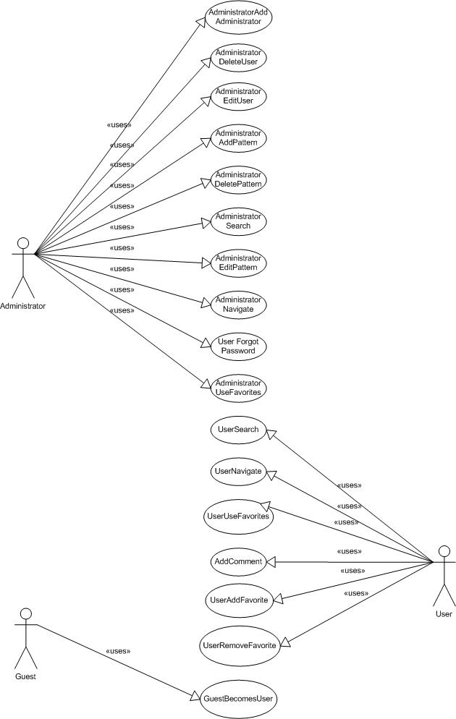

Figure 2.1: Use Case Model

2.2.6 Data Dictionary

User | A user accessing the system via the web to search or browse the database, view Pattern information, add Patterns to a personal Subset, print Pattern descriptions, and post Comments about specific Patterns. A User is identified by a username unique throughout the entire system.
  username : String | The User's identification. Unique across all Users.
  password : String | Password chosen by the User.
  name : String | The name of the User.
  email : String | A valid email address for the User.
  affiliation : String | An organization name or mailing address for the User.
  status : common, admin | Defines the permissions the User has.
Administrator | A User with ‘admin’ status. An Administrator has all of the permissions of a User, in addition to permissions to add, edit or delete Users, and add, edit or delete Patterns.
Guest | A visitor to the system website that is not a registered User. A Guest may not access system functions but may request registration from the main webpage.
Pattern | An empirically tested solution to a recurring problem in chemical education. Consists of a unique name, zero or more synonyms, the name of the author, a headline, an abstract, a body, a solution, zero or more Diagrams, and a list of Patterns linked to the Pattern.
  name : String | The name of this Pattern. Unique across all Patterns.
  synonym : Array | Alternate names for this Pattern.
  author : String | The author of this Pattern.
  headline : String | A brief description of the problem addressed.
  abstract : String | An overview of the pattern solution.
  body : String | A full description of the problem addressed by this Pattern, including the empirical background and supporting evidence.
  solution : String | A full description of the solution to the problem being addressed.
  example : image, movie, animation | Diagrams illustrating the solution.
  context : Array | Patterns of which this Pattern is a part.
  subsystems : Array | Patterns needed to complete this Pattern.
Diagram | An image, animation, or movie used to illustrate a concept in a Pattern. A Diagram is identified by a unique filename.
  filename : String | The name of the file containing the diagram.
Comment | A User's opinion of the effectiveness of a specific Pattern. A Comment is identified by a unique combination of commentID and patternName.
  commentID : integer | A system-assigned integer identifying this Comment. Unique across all Comments for a specific Pattern.
  author : String | Username of the author of this Comment.
  patternName : String | Name of the Pattern this Comment concerns.
  body : String | The text of the comment.
Favorite | A reference to a Pattern chosen by a User. A Favorite is identified by a unique combination of the User’s username, and the Pattern’s name.
  owner : String | The username of the User who assigned the Pattern as a Favorite.
Subset | A collection of Favorites created by a User.

2.2.7 Class Diagram
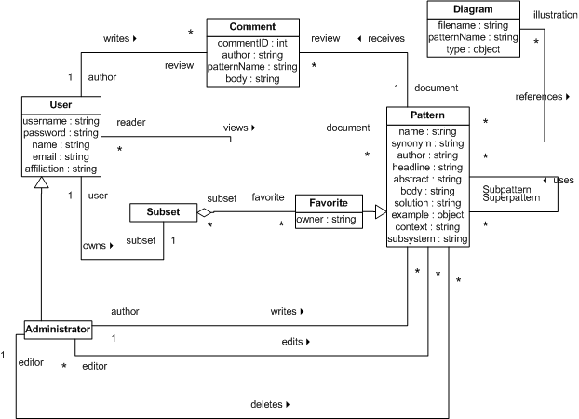

Figure 2.2: Class Diagram
2.2.8 Entity Objects

User A user accessing the system via the web to search or browse the database, view Pattern information, add Patterns to a personal Subset, print Pattern descriptions, and post Comments about specific Patterns. A User is identified by a username unique throughout the entire system.

username : String – the User's identification. Unique across all Users.
password : String – password chosen by the User. Used for authorization.
name : String – the name of the User.
email : String – a valid email address for the User.
affiliation : String – an organization name or mailing address for the User.
status : common, admin – defines the permissions the User has.

Administrator A User with ‘admin’ status. An Administrator has all of the permissions of a User, in addition to permissions to add, edit or delete Users, and add, edit or delete Patterns.

Guest A visitor to the system website that is not a registered User. A Guest may not access system functions but may request registration from the main webpage.

Pattern An empirically tested solution to a recurring problem in chemical education. Consists of a unique name, zero or more synonyms, the name of the author, a headline, an abstract, a body, a solution, zero or more Diagrams, and a list of Patterns linked to the Pattern.

name : String – the name of this Pattern. Unique across all Patterns.
synonym : String – alternate names for this Pattern.
author : String – the author of this Pattern.
headline : String – a brief description of the problem addressed.
abstract : String – an overview of the pattern solution.
body : String – a full description of the problem addressed by this Pattern, including the empirical background and supporting evidence.
solution : String – a full description of the solution to the problem being addressed.
example : image, movie, animation – diagrams illustrating the solution.
context : Array – Patterns of which this Pattern is a part.
subsystems : Array – Patterns needed to complete this Pattern.

Diagram An image, animation, or movie used to illustrate a concept in a Pattern. A Diagram is identified by a unique filename.

filename : String – the name of the file containing the diagram.
type : image, movie, animation – the type of the diagram.

Comment A User's opinion of the effectiveness of a specific Pattern. A Comment is identified by a unique combination of commentID and patternName.

commentID : integer– a system-assigned integer identifying this Comment. Unique across all Comments for a specific Pattern.
author : String – username of the author of this Comment.
patternName : String – name of the Pattern this Comment concerns.
body : String – the text of the comment.

Favorite A reference to a Pattern chosen by a User. A Favorite is identified by a unique combination of the User’s username, and the Pattern’s name.

owner : String – username of the User who chose the Pattern.
pname : String – name of the Pattern chosen to be a favorite.

Subset A collection of Favorites created by a User.

2.2.9 Boundary Objects

AdministrativeOptionsForm Form containing all special options available to an
Administrator. This form is presented when an
Administrator logs into the system. From this form an Administrator may choose to edit or delete Users, assign existing Users Administrator permissions, add, edit or delete
Patterns, or search the pattern database.

UserListingForm Form listing all current User accounts. This form is presented when an Administrator invokes the
AdministratorAddAdministrator, AministratorEditUser,
or AdministratorDeleteUser use cases.

UserInformationForm Form containing fields for editing all information relevant to a User, as well as options to delete the account or grant it Administrator privileges. This form is presented when an Administrator selects an account from the UserListingForm to modify. This form is used to edit the data of an existing User,
delete an existing User, or grant an existing User
Administrator privileges.

AdministratorAddButton Button used by the Administrator to grant a standard User Administrator permissions. Presented on the UserInformationForm.

UserSaveButton Button used by the Administrator to save the new information for an existing User who’s information has been edited.

UserDeleteButton Button used by the Administrator to delete an existing User.

PatternEntryForm Form containing fields for entering all information relevant to a Pattern. This form is presented when an Administrator invokes the AdministratorAddPattern or
AdministratorEditPattern use case. This form is used to enter data for a new Pattern or edit the data of an existing Pattern.

PatternAddButton Button used by the Administrator to add a new Pattern.

PatternSaveButton Button used by the Administrator to save the new information for an existing Pattern who’s information has been edited.

PatternDeleteButton Button used by the Administrator to delete an existing Pattern.

DeletePatternsForm Form asking the Administrator for confirmation on which (if any) of the "dead-end" Patterns linked to the Pattern being deleted should also be deleted. This form is presented after the Administrator invokes the AdministratorDeletePattern use
case.

DatabaseSearchForm Form used for specifying terms to search for in the Pattern database, for use of the Favorites Subset, and also lists all of the Patterns in the database in hierarchical order. This form is presented when a User invokes the SearchDatabase use case. The User can search by Pattern name, synonyms, author, or headline. The hierarchical list shows only the Pattern names.

SearchResultsForm Form listing Patterns that match the search terms entered in the SearchDatabase use case. This form is presented after an Administrator or User submits a set of search terms.

DiagramUploadForm Form used to upload an image, animation, or movie to the database server for use in a Pattern. This form is presented in the AdministratorAddPattern and AdministratorEditPattern use cases, if the Administrator selects the "Upload Diagram" function.

PatternDisplayForm Form listing the full description of the selected Pattern. This form is presented when the User selects a specific pattern to view through either the SearchDatabase or NavigateDatabase use case. The form offers navigation via Pattern linkages, as
well as options to mark the Pattern as a Favorite or remove the Pattern from the Favorites.

AddCommentForm Form allowing the User to comment on a specific Pattern. This form is presented when the User invokes the AddComment use case.

RetrievePasswordForm Form requesting the username of the account to retrieve the password for. This form is presented when the User invokes the UserForgotPassword use case.

RegistrationRequestButton Button used by a Guest to initiate the GuestBecomesUser use case.

UserRegistrationForm Form listing all required and optional information fields for a User. This form is presented to the Guest in the GuestBecomesUser use case.

SubmitRegistrationButton Button used by a Guest to submit the information required for access to the system.

2.2.10 Control Objects

AddPatternControl Manages the addition of a new Pattern to the database. This object is created when an Administrator selects the "Add Pattern" function. It creates a blank PatternEntryForm and presents it to the Administrator. After submission of the form, it validates the data entered. If the data is valid, it collects the data and stores it in the database as a new Pattern. If the data is invalid, it presents the PatternEntryForm to the Administrator with the data entered and indicates which data needs to be corrected. The object notifies the Administrator if
the Pattern was successfully added.

EditPatternControl Manages the editing of an existing Pattern from the database. This object is created when an Administrator selects the "EditPattern" function. It creates a PatternEntryForm filled with the data of the Pattern selected and presents it to the Administrator. After submission of the form, it validates the data entered. If the data is valid, it collects the data and uses it to update the selected Pattern. If the data is invalid, it presents the PatternEntryForm to the Administrator with the data entered and indicates which data needs to be corrected. The object notifies the Administrator if the Pattern was successfully updated.

DeletePatternControl Manages the deletion of an existing Pattern from the database. This object is created when an Administrator selects the "DeletePattern" function. It first determines if any Patterns linked to the Pattern being deleted will no longer have any
valid linkages ("dead-end" Patterns). If such Patterns exist the object presents the Administrator with a DeletePatternsForm. After submission of that form, the object deletes the selected Patterns from the database and notifies the Administrator.

UploadDiagramControl Manages the uploading of Diagrams onto the server. This object is created when an Administrator selects the "UploadDiagram" function on a PatternEntryForm. It presents the Administrator with a common file dialog box. Upon the return
of that dialog box, if a valid file was selected, the object initiates the upload of the file. After completion of the upload and successful submission of the PatternEntryForm, the object permanently saves the file and links it to the Pattern.

ViewAccountControl Manages the selection and viewing of an existing User account. This object is created when an Administrator selects the "User Information" option on the AdministrativeOptionsForm. It first presents the Administrator with a UserListingForm. Once the Administrator has chosen an account to view or
modify, it presents the Administrator with a UserInformationForm for that account. The object then creates a new control object based on the Administrator's next action and passes control to that object. Once control is passed back the object returns to the UserListingForm.

AddAdministratorControl Manages the creation of a new Administrator account from an existing User account. This object is created when the Administrator clicks the AdministratorAddButton on the UserInformationForm. This object is created by a
ViewAccountControl object and given control. The object modifies the account, notifies the Administrator of the successful change, and passes control back to its parent ViewAccountControl object.

DeleteUserControl Manages the deletion of an existing User account. This object is created when the Administrator clicks the UserDeleteButton on the UserInformationForm. This object is created by a ViewAccountControl object and given control. The object deletes the account, notifies the Administrator of the successful deletion, and passes control back to its parent
ViewAccountControl object.

EditUserControl Manages the editing of an existing User account. This object is created when the Administrator clicks the UserSaveButton on the UserInformationForm. This object is created by a ViewAccountControl object and given control. The object validates the data entered, and modifies the account if all data is
valid. If any data is invalid, the object returns the
UserInformationForm and indicates which data needs to be corrected. The object notifies the Administrator of the successful modification, and passes control back to its parent ViewAccountControl object.

SearchDatabaseControl Manages the search engine for the database. This object is created when a User enters search terms in a DatabaseSearchForm and then selects "Search". It searches the database for all Patterns matching the search terms entered by the user. After it has found all matching Patterns, it collects them and presents a SearchResultsForm to the user.

NavigateDatabaseControl Manages navigation through the database via Pattern linkages and the Favorites Subset. This object is created whenever a User selects a superpattern or subpattern link from a PatternDisplayForm, or a Favorite from the DatabaseSearchForm. The object presents the User with a PatternDisplayForm containing the information of the Pattern navigated to.

AddFavoriteControl Manages the addition of a Pattern to the User's Favorites. This object is created when a User invokes the UserAddFavorite use case. The object adds the Pattern to the User's Favorites and notifies the User.

RemoveFavoriteControl Manages the removal of a Pattern to the User's Favorites. This object is created when a User invokes the UserRemoveFavorite use case. The object removes the Pattern from the User's Favorites and notifies the User.

AddCommentControl Manages the addition of a Comment to a specific Pattern. This object is created when the User invokes the AddComment use case. It presents the User with an AddCommentForm. Upon submission of this form, it stores the Comment and associates it with the Pattern.

GuestRegistrationControl Manages the registration of a Guest. This object is created when a Guest selects the RegistrationRequestButton. It first presents the Guest with a UserRegistrationForm. Upon submission of that form, the object validates the data entered. If any data is invalid, it returns the form to the Guest, indicating which data need to be corrected. If all data is valid, the object creates a new User account and notifies the Guest of the
successful registration.

RetrievePasswordControl Manages the retrieval of User passwords for Users who have forgotten. This object is created when a User invokes the UserForgotPassword use case. The object presents the User with a RetrievePasswordForm. Upon submission of the form, the object checks for a User account with the given username. If no such account is found, the User is notified that the username entered is invalid. If an account is found, the object emails the password to the address registered with that account and notifies the User of such.
2.2.11 Screen Mockups
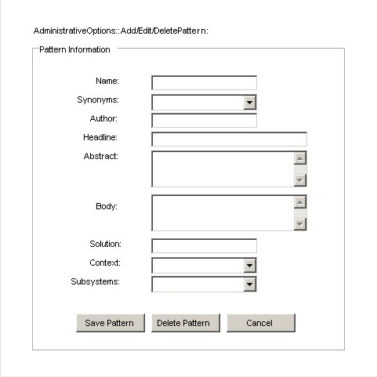
Figure 2.3: Add/Edit/Delete Pattern Screen
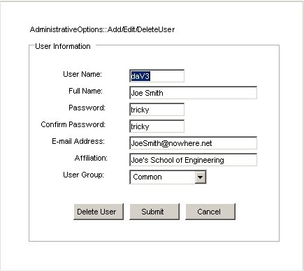
Figure 2.4: Add/Edit/Delete User Screen

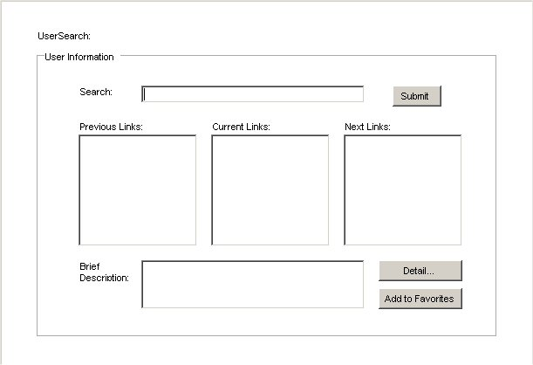
Figure 2.5: User Search Screen
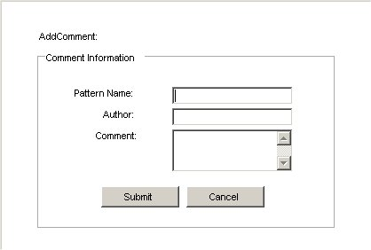
Figure 2.6: Add Comment Screen

Section 3: System Design

3.1 Introduction
3.1.1 Purpose of the System

The purpose of the system is to aid in the creation of a pattern language. A pattern language is a hierarchy of patterns. Each pattern holds a solution to a problem, and lists any patterns that are sub-patterns (meaning they solve part of the problem) and lists any super-patterns (meaning that they solve part of the super-pattern’s problem). After the language is created by the user, it can be refined and updated. Upon completion of the pattern language, the system can be used to interactively learn from the existing pattern by navigating the pattern language using sub-pattern and super-pattern links.

3.1.2 Design Goals

Security: The administrator’s privileges must not be accessible to other users. Administrators have potentially damaging privileges.

Availability: The system will be available to anyone with access to the internet.

Development Cost – The client does not expect to pay any money for the delivery of the system.

Readability – The code of the system will be a deliverable, and the client to have other people maintain the project. The readability of the code is important.

3.2 Current System

This system is not replacing any current system. The pattern language planned to be stored on our system has not been created yet.

3.3 Proposed Software Architecture

3.3.1 Overview

The system will be run on two servers. One server will host the database that contains the information about the patterns and users. The other server will respond to web page requests. The users will run a web browser on their PC access our system. We split the system up into seven subsystems. The user interface subsystem will handle user input. The User Manipulation System will be responsible for all changes that are made to user data. The pattern manipulation subsystem is responsible for all changes that are made to the pattern data. The search subsystem is responsible for handling user searches and querying the database. The navigation subsystem is responsible for the navigation from pattern to pattern using the sub-pattern and super-pattern links. The communication subsystem is responsible for connecting the database to the other subsystems. The database subsystem is responsible for storing all of the pattern and user data.

3.3.2 Subsystem Decomposition

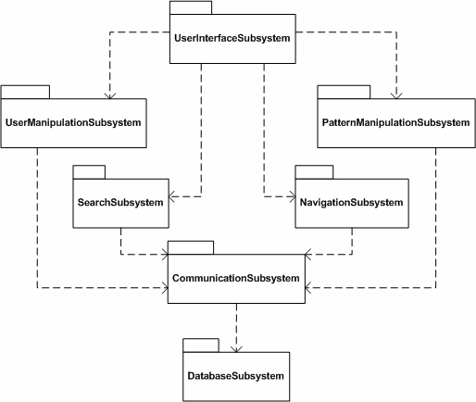
Figure 3.1: Subsystem Diagram

User Interface Subsystem

The user interface subsystem consists of all of the screens that will make up the program. These screens include: User Login screen, Add/Edit/Delete Pattern screen, Add/Edit/Delete User screens, Search screens, and Pattern Display screens. The user interface is responsible for displaying the correct screen and information to the user. It is also has the responsibility of letting the user access the other subsystems of the program, such as the user manipulation subsystem.

User Manipulation Subsystem

The user manipulation subsystem is responsible for all changes that are made to user data. This includes the addition of a new user, the deletion of an existing user, or the editing of an existing user. This subsystem uses the communication subsystem to interact with the database in order to manipulate the user data. The editing and deleting of users will only be accessible by administrators. The add user feature is available to everyone.

Pattern Manipulation Subsystem

The pattern manipulation subsystem is responsible for all changes that are made to the pattern data. This includes the addition of a new pattern, the deletion of an existing pattern, or the editing of an existing pattern. In the case of deleting a pattern, it is the responsibility of this subsystem to update the links for the pattern. The links will be updated based on the response of the administrator who deletes the pattern. This subsystem uses the communication subsystem to interact with the database in order to manipulate the pattern data. The pattern manipulation subsystem is only accessible by administrators.

Search Subsystem

The search subsystem is responsible for handling user searches and querying the database. The user can search by entering a keyword to search for, or the user can search through a list of the patterns. When searching with a keyword the user can specify which field of the pattern the keyword is to be searched for, such as the title or description. Once the keyword and field information is given, or a pattern is chosen from the list, the search subsystem sends a query to the database using the communication subsystem. The search subsystem is accessible by all users.

Navigation Subsystem

The navigation subsystem is responsible for the navigation from pattern to pattern using the sub-pattern and super-pattern links. The navigation subsystem is also responsible for the users ability to link to any media that may be attached to a pattern. This subsystem uses the communication subsystem to access the database. This subsystem is available to all users.

Communication Subsystem

The communication subsystem is responsible for communication between the database and the other subsystems. All of the subsystems except for the User Interface is connected to this subsystem. This subsystem is not directly accessed by the user, but is indirectly used every time the database must be accessed.

Database Subsystem

The database subsystem is responsible for storing all of the pattern and user data. The database will be a Microsoft Access database, as requested by the client. The database is accessed through the communication subsystem by the other subsystems.

3.3.3 Hardware/Software Mapping

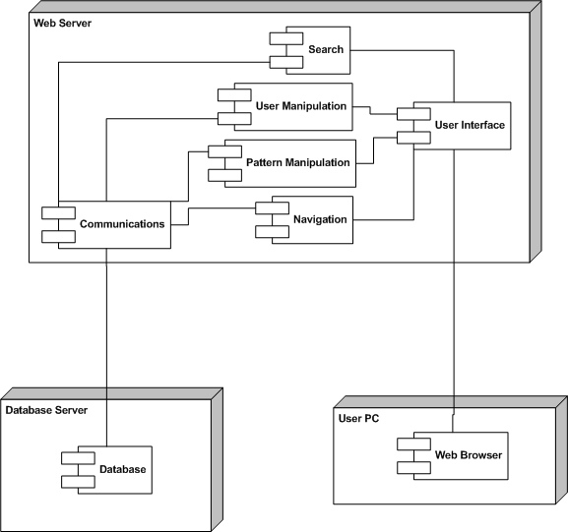
Figure 3.2: Hardware/Software Mapping Diagram

This diagram shows how our system will work together with hardware. Two machines will be used to run our system. The web server will service the web requests that the users send, and the database server will service requests that the Communications subsystem requires.

3.3.4 Persistent Data Management

The application will use a Microsoft Access database to store Pattern and User data, and a local hard disk to store images, movies, and animations as flat files. These files will be referenced by Patterns by filename only. The ‘type’ of these files (movie, image, or animation) will be stored in the database along with the filenames, to allow our application to easily treat displaying these files differently. (Specifically, images will be immediately displayed, while links will be provided to animations and movies.) The web interfaces and server will be stored on a separate hard disk.

Database Schema (DDL Specification)

Pattern(patternName, author, headline, abstract, body, solution)
Primary Key(patternName);

Synonym(patternName, patternAlias)
Primary Key(patternName, patternAlias)
Foreign Key(patternName) References Pattern

Linkage(patternName, patternLink)
Primary Key (patternName, patternLink)
Foreign Key (patternName) References Pattern
Foreign Key (patternLink) References Pattern(patternName)

Example(filename, patternName, type)
Primary Key (filename, patternName)
Foreign Key (patternName) References Pattern

User(username, password, fname, lname, email, affiliation, admin)
Primary Key (username)

Comment(commentID, author, patternName, body)
Primary Key (commentID)
Foreign Key (patternName) References Pattern
Foreign Key (author) References User(username)

Favorite(username, patternName)
Primary Key (username, patternName)
Foreign Key (username) References User
Foreign Key (patternName) References Pattern
3.3.5 Entity Relationship Diagram

The Entity Relationship Diagram for the application database is shown below. The tables in this diagram have been normalized and may be directly implemented in a relational database. The diagram also shows Access data types for the various attributes.

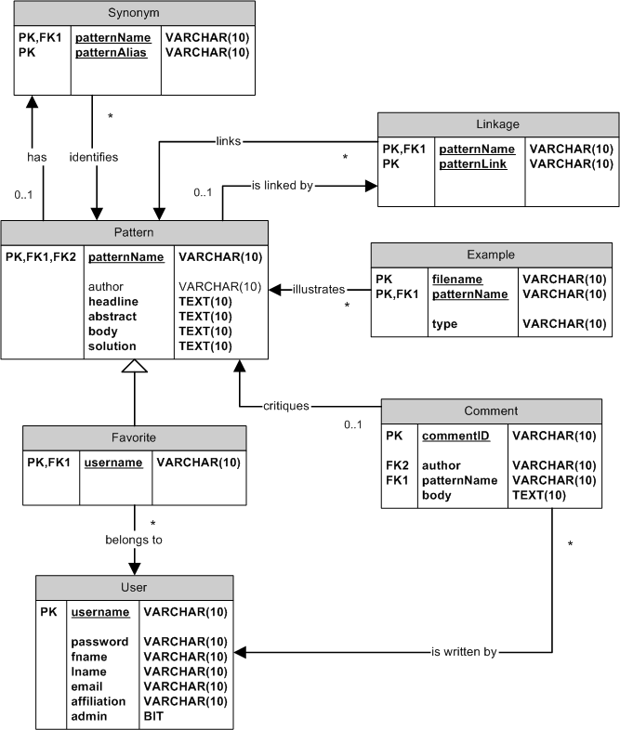
Figure 3.3: Entity Relationship Diagram

3.3.6 Access Control and Security

The functionality of the system will be split into two groups – administrators and users. Only users that are administrators may add or delete a pattern, and an administrator may only be added by another administrator. All users may view patterns, except for the special user, Guest, which may only apply for access to the system. The relative access matrix is defined as:

 | Users | Patterns
Administrators | AdministratorAddAdministrator  AdministratorDeleteUser  AdministratorEditUser  AdministratorSearch | AdministratorAddPattern  AdministratorDeletePattern  AdministratorEditPattern  AdministratorNavigate  AdministratorUseFavorites
Users | GuestBecomesUser  UserForgotPassword | UserSearch  UserNavigate  UserAddFavorite  UserRemoveFavorite  UserUseFavorites

3.3.7 Global Software Control

The Pattel system is event-driven in nature. The system interacts with the client through a web-based interface, and facilitates users’ requests through a backend database server.

The database will be a Microsoft Access database, as specified by the client. The web frontend will be simple HTML, with C# and ASP components for accessing the database, as necessary.

3.3.8 Boundary Conditions

Because we are using ASP.NET, there are no significant boundary conditions for staring up the server. The code is automatically compiled upon the first request for the web page. The server should not shut down, but the information should be saved in the database when the system does shutdown.

Section 4: Project Plan

4.1 Overview

4.1.1 Objective

The purpose of the system is to aid a user in the creation of a pattern language. After the user creates the language, it can be refined and updated. Specifically, the pattern languages that will be created by users of the system will deal with pedagogical practices in the field of chemistry. Upon completion of the pattern language, the system can be used to interactively learn from the existing pattern.

4.1.2 Discussion

The client for this project is Dr. Susan Wiediger, Department of Chemistry at Southern Illinois University-Edwardsville, Illinois. Dr. Wiediger has experience with pattern languages and is interested in the development of a tool to help in the creation and search of pattern languages. The system should be easily accessible (web-based frontend), and should allow the user to search for existing patterns (database backend server). The contractor for this project is Dr. Bernard Waxman, Department of Computer Science at Southern Illinois University-Edwardsville, Illinois.

4.1.3 Detail

Figure 4.1 shows the Gantt Chart for the Pattel team for the Fall 2003 Semester.

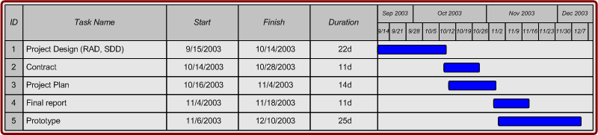

Figure 4.1: Gantt Chart for Fall 2003

Figure 4.2 shows the Gantt Chart for the Pattel team for the Spring 2004 Semester.

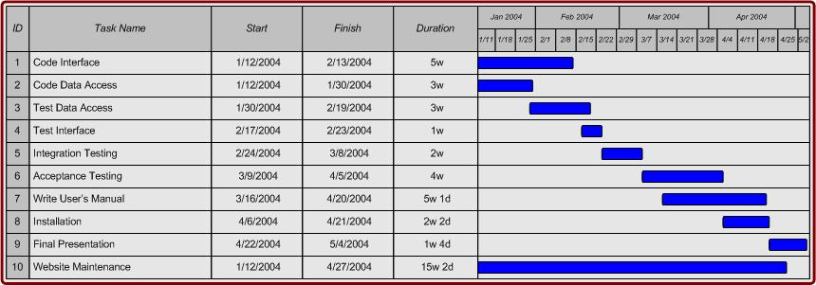
Figure 4.2: Gantt Chart for Spring 2003

4.2 Process Plan

4.2.1 Objective

The objective of the process plan is to separate the development of the system into a series of time measured slots called “processes”.

4.2.2 Discussion

Pattel has chosen to use the “Waterfall with Subprojects” lifecycle model. This model supports the gathering of risks and requirements in the beginning stages, and then divides the system into subsystems that can be worked on in parallel to better utilize time. Pattel has met with the client, Dr. Susan Weidiger, on more than one occasion to discuss the project and it’s requirements in detail. The team feels that this model best fits this project since the risks and requirements for this project are well defined in the early stages, and that the system can be broken down into subsystems that are not interdependent. With this in mind design, coding, and testing of the separate subsystems can be done simultaneously. Once the subsystems are completed they can be integrated to form the system. The system can then be tested and delivered on or before the scheduled release date.

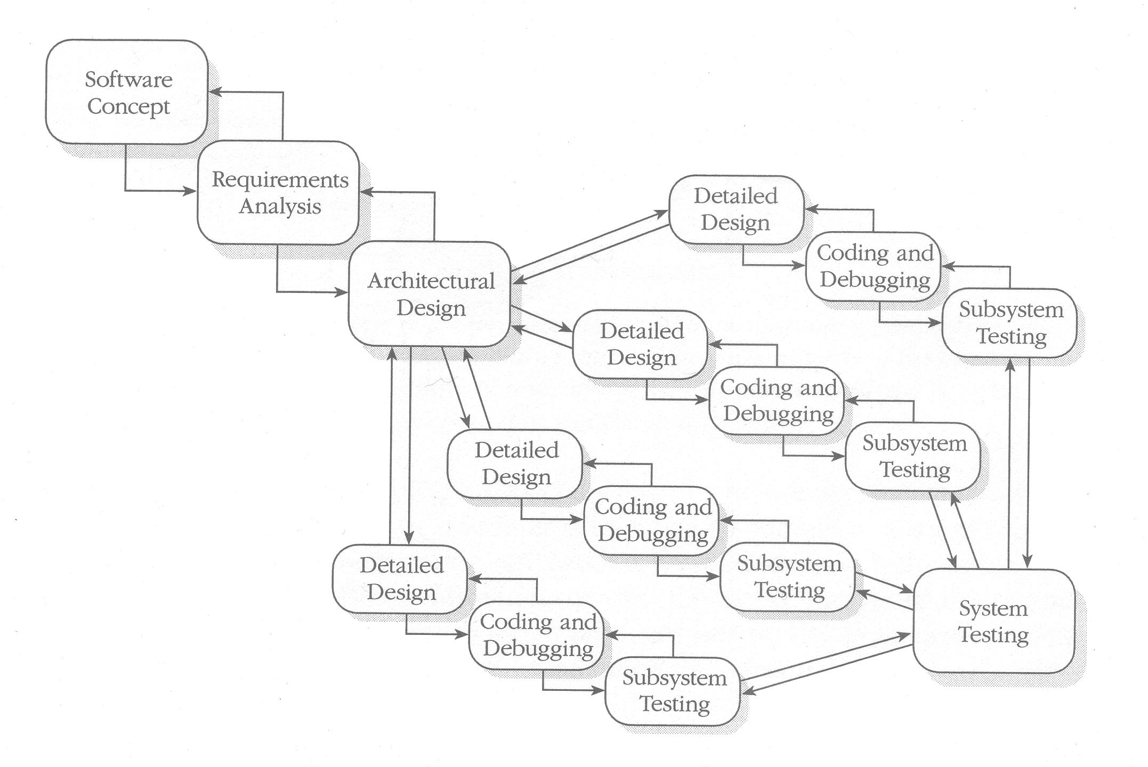

Figure 4.3: Waterfall with Subprojects
Rapid Development, 1996

4.2.3 Detail

4.2.3.1 Definition Process

- Analyze Problem
Develop an understanding of the problem at hand, and generate a realization of the projects needs and the client’s requirements.

- Acceptance Criteria
Criteria for client acceptance and project success will be based on the requirements of the client, and the teams understanding of the problem. For this project, Pattel has determined that for this project to be a success the system must perform all required tasks without flaws. These tasks include creating a web-based interface that will communicate with a database housed on a separate server, and perform typical operations on the database.

- Project Tools
- Microsoft C# (C sharp)
- ASP.NET
- Microsoft Access
- Microsoft Word
- Microsoft PowerPoint

4.2.3.2 Design Process

4.2.3.2.1 Primary Objectives

- Design Operational Programs
The project will be divided into subsystems that can be created independent of one another. The functionality of each subsystem will be defined during this process.

- Conduct Project Review
Prior to programming, a thorough review of the project is done for assurance that the system is designed to best fulfill the projects requirements and expectations.

4.2.3.2.2 Secondary Objectives

  - Prepare for Integration Testing
Prior to subsystem integration, each subsystem will be tested extensively for correctness.
  - Set Up Change Management
The team feels that it is not likely that any major changes will occur to this project, however the team is able to accommodate any changes that are necessary.

  - Prepare for Programmer Training
All team members will need to be trained to work with the tools needed for this project. An above average knowledge of the tools will be needed for the team members to complete this project satisfactorily.

4.2.3.3 Programming Process

- Do Detailed Design, Coding, and Module Test
The project is separated into subprojects or modules. Each module is designed in detail prior to any coding. After coding extensive testing will be done on each module to ensure correctness. After testing the modules will be integrated.

- Integrate Modules
Once individual module testing is done on all modules, the modules will be integrated into one system. The system will then be tested to assure module interconnectivity.

- Document
Every section of the project, including the sections within the modules, will have documentation on functionality and what information is communicated.

4.2.3.4 System Test Process

4.2.3.4.1 Primary Objectives

- Test System Against Problem Specification
The system will be tested thoroughly against all aspects of the proposed problem. If any failures occur, the system will be corrected and re-tested until performance of the system is satisfactory.

- Test as “Live” as Possible
Tests will be conducted using the servers that are available to us in the Engineering building. The database and code will be put on separate servers for testing, just as the client will use them.

- Test by Nonprogrammers
The programmers will initially test the system, but nonprogrammers will do further testing to ensure correct operation of the system.

4.2.3.4.2 Secondary Objectives

- Train Customer
Train customer on how to use the system and all of its functionality.

- Complete User Documentation
Documentation will be provided to the user explaining in detail how to use the system and all of its functionality.

4.2.3.5 Acceptance Process

4.2.3.5.1 Primary Objectives

- Execute and Analyze Acceptance Tests
Conduct a test session involving the client to show the success of the system, and to gain the clients acceptance.

- Sign Formal Acceptance Agreement
Once the system passes the acceptance test, the client will sign a formal agreement stating the client’s acceptance of the provided system.

4.2.3.5.2 Secondary Objectives

- Complete Customer Training
Customer training will be completed in this process, if it was not completed in the previous process.

- Clean up Documentation
Finalize all project documentation, including user documentation. Check for completeness and readability.

4.2.3.6 Operational Process

4.2.3.6.1 Primary Objective

- Assist in Beginning Operation
All team members will be available to assist the client for the beginning operation.

- Evaluate Project
Upper management will evaluate the project upon its completion in April or May 2004.

4.3 Organization Plan

4.3.1 Objective

The objective of this section is to define the organization of the Pattel team and assign roles to the team members.

4.3.2 Discussion

The Organization Plan provides an explanation of each team member’s role and responsibilities. Each person in the Pattel team has certain responsibilities. Everyone in the team will be responsible for helping fellow team members complete tasks.

4.3.3 Team and Their Responsibilities

4.3.3.1 Project Manager

Daniel Harrington is the Project Manager. He will be the main link between the team and upper management. He must keep both the Pattel team and upper management updated. Daniel must ensure that project goes smoothly and is completed on time.

4.3.3.2 Lead Analyst and Lead Tester

Chris Fleenor is the lead analyst. He is responsible for maintaining the requirements of the project. He should have the best understanding of requirements to make a good mediator for the team and the client. Chris is also the Lead Tester. He is responsible for ensuring that thorough testing is completed for each phase of testing described in this document.
4.3.3.3 Lead Documenter

Andrew Miles is the lead documenter. His duties for this job include keeping all of the documents up to date, consistent, and available on the website.

4.3.3.4 Lead Designer and Lead Programmer

Brian Bogovich is the lead designer. He is responsible for the database design, system design, and the project website. Brian is also the Lead Programmer. He is responsible for maintaining the vision of the entire program. He will help in deciding who needs to program each module.

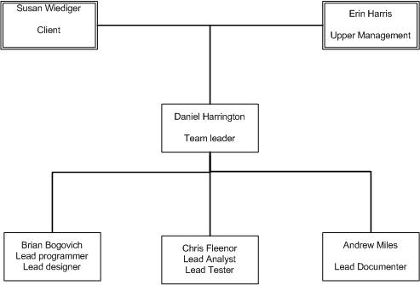
Figure 4.4: Organization Chart

4.4 Test Plan

4.4.1 Objective

The objective of this section is to define the tools, procedures and responsibilities for conducting all levels of test of the software system.
4.4.2 Discussion

4.4.3 Detail

4.4.3.1 Module Test

Testing done on the individual program modules before they are integrated with other modules.

4.4.3.1.1 Module Test Objectives
Module testing is done to ensure that each module functions correctly. If each module does work correctly, then integration testing will go much more smoothly.

4.4.3.1.2 Module Test Responsibility
The member of the team that programs a module will be responsible for testing that module before it is considered completed.

4.4.3.1.3 Module Test Procedures
White box testing will be used to make sure that the internals of the modules are working correctly. Equivalence testing will also be used to make sure the module works correctly.

4.4.3.1.4 Module Test Tools
Drivers and stubs can be used to test the modules individually. Visual Studio can help debugging by stepping through the program, allowing us to check values inside the module.

4.4.3.2 Integration Testing

4.4.3.2.1 Integration Test Objectives
The purpose of integration testing is to ensure that each module works with the other modules correctly. The output of each module should be correct if module testing was done correctly. Integration testing will focus more on the connections between modules.

4.4.3.2.2 Integration Test Responsibilities
The lead programmer will be responsible for the integration testing. The whole team may be active in integration testing as a whole, but the lead programmer will be the one person responsible.

4.4.3.2.3 Integration Test Procedures
The integration of modules will be done one at a time. After each module is added connected to the system, that module will be tested by using its functionality with other modules. Any errors that we find must be fixed before more modules are added.

4.4.3.2.4 Integration Test Tools
Drivers and stubs will be required before all of the modules are connected to the system.

4.4.3.3 System Test

4.4.3.3.1 System Test Objectives
The purpose of system testing is to ensure our system fulfils all of the functional and nonfunctional requirements. The testing should be broad enough to cover all of the functionality of the system.

4.4.3.3.2 System Test Responsibility
The whole team will be responsible in testing the system.

4.4.3.3.3 System Test Procedures
New patterns will be added to our system to allow for testing. These new patterns will not necessarily be real, but could be filler so that we can test a larger volume of data. The rest of the testing will be focused at boundary conditions, and normal use.

4.4.3.3.4 System Test Tools
We will have to have two servers and a client to test the system. We can use lab computers as the clients. The client will give us access to two servers to test our program.

4.4.3.4 Acceptance Test

4.4.3.4.1 Acceptance Test Objectives
The objective of this section is to demonstrate to the client that the system meets all of the needs listed in the project contract.

4.4.3.4.2 Acceptance Test Responsibility
The Project Manager and Analyst are responsible to make sure that the acceptance test is effectively performed with the client.

4.4.3.4.3 Acceptance Test Procedures
The acceptance testing will be done with the client. The client and the team will ensure that the entire functionality defined in the documentation is working.

4.4.3.4.4 Acceptance Test Tools
The acceptance testing will be done on a PC that is connected to the internet. Our system will be running on a server the client chooses.

4.5 Change Management Plan

4.5.1 Objective

The objective of this section is to define the procedures for controlling change in the envolving software system.

4.5.2 Discussion

After the contract is signed by the client and the team, any changes to the project must be approved.

4.5.3 Detail

4.5.3.1 Baselines

4.5.3.1.1 Problem Specification
The problem is defined in the RAD(Requirements Analysis Document).

4.5.3.1.2 Design Specification
The design is defined in the SDD(System Design Document)

4.5.3.2 Proposing a Change

4.5.3.2.1 Who May Propose a Change
(a) Pattel Team members
(b) The client
(c) Upper management(Waxman)

4.5.3.3 Investigating a Proposed Change

4.5.3.3.1 Who, How, When
A change can only be adopted after all team members review the change and make recommendations. The decision to adopt any changes will be based on the impact to the project goals and timelines as outlined in the Project Plan. The Investigator will document all change requests.

4.5.3.3.2 The Investigator’s Report
The Investigator’s report will include the following information:
(a) A summary of the proposed changes
(b) The name of the person requesting the change
(c) Classification of the change
(d) Impact on schedules
(e) Recommendations for the proposed change

4.5.3.4 Change Management Board

4.5.3.4.1 Membership
The Change Management Board is comprised of the Pattel team.

4.5.3.4.2 When it Meets
The Board will meet when a change is proposed.

4.5.3.4.3 How it Operates
The Board will review the changes in question thoroughly. A vote will be taken to decide whether the change is accepted. In case of a tie, the team leader will choose whether to accept the change or not.

4.5.3.5 Types of Recommendations

4.5.3.5.1 Acceptance
If the change is accepted, the contract will be modified to include the change. All other documents may be modified to accept the change. The person requesting the change will be notified about the acceptance.

4.5.3.5.2 Rejection
If the change is rejected, the person requesting the change will be notified about the rejection and reasoning behind it.

4.5.3.6 Implementing a Change

4.5.3.6.1 Approval needed
(a) Project Management(Waxman)
(b) the client
(c) the Pattel Team

4.5.3.6.2 Documenting the Change
After the change is approved, it must be documented. The RAD, and SDD will be updated with the change.

4.5.3.6.3 Scheduling the Change
The schedule for the project must be update after the change approval. If the schedule is unrealistic, the change should not have been approved.

4.6 Documentation Plan

4.6.1 Objective

This section details the resources required for the production of project documentation, as well as outlines for all official documents produced by the development team.

4.6.2 Discussion

Outlines of all project documents are provided in this section. No additional documents will be published unless required by upper management or approved by the project manager.

4.6.3 Detail

4.6.3.1 Publication Procedures and Responsibilities

4.6.3.1.1 Preparation and Approval
The project team discusses the general contents of each document before attempting to write said document. Each member of the team is assigned a specific portion of the document to write, and that member is responsible for completing that portion before the deadline for the document. One team member then compiles the separate portions into a single document and submits the final copy to upper management both electronically and in print.

4.6.3.1.2 Typing
Each team member is responsible for typing any work assigned to them.

4.6.3.1.3 Proofreading and Editing
Each team member is responsible for proofreading and editing all project documents.

4.6.3.1.4 Reproduction
All project documents will be freely available through the project web site. Hard copies will be made only at the request of upper management or the client.

4.6.3.1.5 Distribution
Within the Project - All team members have access to the project web directory via FTP.

To the Client - The client may request an electronic or hard copy of any project document at any time.

Upper Management - Upper management may obtain a copy of the latest version of any project document from the project web site. Hard copies of each document will be presented to upper management at the end of the semester.

4.6.3.1.6 Electronic Storage
All project documents will be stored on the Computer Science File Server. All team members have full access to the documentation.

4.6.3.2 Project Document Contents

4.6.3.2.1 Requirements Analysis Document (RAD)
The RAD fully specifies the expected capabilities of the system, including performance requirements, data requirements, and human interface requirements. It contains all diagrams selected for use during the Definition Process.

4.6.3.2.2 System Design Document (SDD)
The SDD describes, in detail, the structure of the system specified in the RAD. It includes the proposed system architecture, software architecture, and a description of all subsystems making up the proposed system.

4.6.3.2.3 Project Plan
The project plan documents all information necessary to the management of the development of the system. This includes information on the development processes used, management procedures, estimated resource requirements, and estimated development schedules.

4.6.3.2.3 User Manual
The User Manual is a tool for the client. It will show her how to install, and operate the system.

4.7 Training Plan

4.7.1 Objective

The objective of this section is to identify the training required for both the members of the Pattel team and the client.

4.7.2 Discussion

Two types of training are accounted for in this plan, internal and external training. Internal training involves training the members of the team in the use of the programming languages, development tools, and management processes required for this project. External training involves training the client and future users of the system in the installation, maintenance, and use of the system.

4.7.3 Detail

4.7.3.1 Internal Training

4.7.3.1.1 Technical
The members of the project team will provide all required internal technical training themselves, whether individually or as a group.

4.7.3.1.1.1 Languages
The system will utilize a web-based front-end implemented using ASP .NET and C#, therefore all members of the team will need to be familiar with both languages. Online tutorials, samples of source code, and reference books will be used as training resources. Training will primarily be individual.

4.7.3.1.1.2 Operating Systems
The team will need to be familiar with configuring the Internet Information Services (IIS) component included in Microsoft Windows 2000 and XP.

4.7.3.1.1.3 Interfacing with Other Subsystems
The system will use a Microsoft Access database as a back-end, therefore all members of the team will need to be familiar with how to interact with an Access database using ASP .NET.

4.7.3.1.2 Non-Technical
All team members are currently enrolled in the Senior Project course (CS425), which will provide training in management techniques, change management techniques, and documentation control.

4.7.3.2 External Training

4.7.3.2.1 Installation
In the event that the system must be re-installed (e.g., hard drive failure), instructions will be provided for configuring IIS and the Access database. A skeleton of the system database as well as all ASP webpages will be provided on a CD.

4.7.3.2.2 Using the System
A User's Manual will be provided with the system, however no formal training will be provided.

4.7.3.2.3 Maintenance
The individual responsible for system maintenance after the delivery of the system is familiar with Microsoft Access, ASP .NET and C#. The source code for the interfaces will be well documented to aid in system maintenance and modification.

4.7.3.3 Resources
No training resources will be needed for this project.

4.8 Review and Reporting Plan

4.8.1 Objective

This section outlines the means by which reviewing and reporting progress will be achieved with this project.

4.8.2 Discussion

All team members will report weekly progress to the team leader, who will submit summarized bi-weekly reports to the contractor for evaluation. Each team member will have individual assignments that he is responsible for completing, which will then be reviewed by the entire team prior to final submission.

4.8.3 Detail

4.8.3.1 Reviews

4.8.3.1.1 Internal Reviews
Each internal review will be conducted by the members of the Pattel Team.

- Definition of Process Review
When: The Definition Process Review will be conducted at the end of the definition process.
Objectives: The objectives of the Definition of Process Review will be to determine readiness for the Design Process, and to evaluate the Project Plan.

- Preliminary Design Review
When: The Preliminary Design Review will be conducted midway into the Design Process.
Objective: The objective of the Preliminary Design Review will be to review the baseline design to ensure validity of the design approach.

- Design Process Review
When: The Design Process Review will be conducted at the end of the
Design Process.
Objectives: The objectives of the Design Process Review will be to review the Design Specifications to evaluate whether or not it satisfies the Problem Specification, and to review the Project Plan to include outside reviewers.

- Programming Process Review
When: The Programming Process Review will be conducted at the end of the Programming Process.
Objectives: The objectives of the Programming Process Review will be to determine readiness for the System Test Process, and to review program documentation.

- System Test Process Review
When: The System Test Process Review will be conducted at the end of the System Test Process.
Objectives: The objectives of the System Test Process Review will be to determine readiness for the Acceptance Process, and to review program documentation.

- Postmortem Review
When: The Postmortem Review will be conducted at the end of the Acceptance Process.
Objective: The objective of the Postmortem Review will be to review and approve the Project History document.

4.8.3.1.2 External Reviews
Each external review will be conducted by the representatives of the contractor and client.

- Preliminary Design Review
When: The Preliminary Design Review will be conducted midway into the Design Process, after the respective internal review.
Objective: The objective of the Preliminary Design Review will be to review the validity of the design approach.

- Design Review
When: The Design Review will be conducted at the end of the Design Process, after the respective internal review.
Objective: The objectives of the Design Review will be to evaluate the Design Specification, and prepare to enter the Programming Process.

- Acceptance Review
When: The Acceptance Review will be conducted at the end of the Acceptance Process.
Objective: The objective of the Acceptance Review will be to review the final product, and identify, if any, remaining problems that must be corrected before the client will formally accept the product.

4.8.3.1.3 Formal Inspections
Formal Inspections will be conducted by the team leader after completion of any product of the project.

4.8.3.2 Reports

4.8.3.2.1 Generated by Team Members
(a) Frequency: Weekly
(b) To: Team Leader
(c) Format: Technical Status Report
(d) Scope: Work in progress

4.8.3.2.2 Generated by Team Leader
(a) Frequency: Bi-weekly
(b) To: Contractor
(c) Format: Technical Status Report
(d) Scope: Work in progress

4.9 Installation and Operation Plan

4.9.1 Objective

This section outlines the responsibilities of the project team for installing and operating the software.

4.9.2 Discussion

The system will require a server that will contain the database of pattern languages. Administration of the database will be conducted by the project team until after the Acceptance Process is complete, after which it will be the responsibility of the client to facilitate management of the database.

4.9.3 Detail

4.9.3.1 Installation
Since the user interface will be web-based, no additional applications will be required to be installed except for an up-to-date web browser. The server will have to be able to accommodate a Microsoft Access Database.

4.9.3.1.1 Responsibility
It will be the responsibility of the client to provide a server which may accommodate the database.

4.9.3.1.2 Schedule
A meeting with the client will be held to demonstrate use of software through local web browser.

4.9.3.1.3 Migration
There is no current system architecture that which this project will replace. For this reason, there will be no migration.

4.9.3.1.4 Introduction of Data
(a) Who gathers data: The initial database will consist of patterns provided by the client, after which patterns may be contributed from any user.

(b) Who validates data: The client and administrators are responsible for the validation of data.

(c) Who manages the data conversion process: During the developmental phases, the project team will be responsible for converting patterns into a format reproducible in the database.

4.9.3.1.5 Multiple-Site Considerations
(a) Site installation teams: The interface to the browse the pattern languages will be accessible through any up-to-date web browser.

(b) Site-to-site coordination: Site-to-site coordination will not effect the functionality of the system on a local workstation.

4.9.3.2 Operation

4.9.3.2.1 Responsibility for Operation
The responsibility for operation of the system will be held by the project team until the Acceptance Process has been completed, at which time the responsibility for operation of the system will be transferred to the client.

4.9.3.2.2 Responsibility for Maintenance and Tuning
The responsibility for the maintaining and tuning of the system will be held by the project team until the Acceptance Process has been completed, at which time the responsibility for the maintaining and tuning of the system will be transferred to the client.

4.9.3.2.3 Duration of Responsibilities
The project team will hold full responsibility of the system until the Acceptance Process has been completed, at which time the responsibility of the system will be transferred to the client.
4.10 Resources and Deliverables Plan

4.10.1 Objective

This section summarizes the estimated resource requirements and delivery schedules for the project.

4.10.2 Discussion

This section details the human and computer resources needed for the completion of the project. It also lists the estimated schedules for all project deliverables and all milestones used to gauge the progress of the project.

4.10.3 Detail

4.10.3.1.1 Manpower

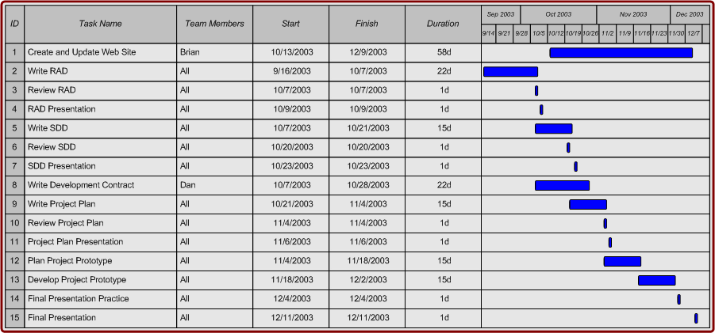

Figure 4.5: Fall 2003 Manpower Chart

This chart shows how the manpower was divided for the fall 2003 semester.
4.10.3.2 Computer Resources
All computer resources have been or will be provided by the client. Specific resource requirements are listed below.

Web Servers - The project web site is served by the Computer Science File Server (http://csfs3.siue.edu). The system will require a dedicated web server to host the web-based interface. This machine will be provided by the client.

Database Server - The system will require a database server to host the Access database. This machine will be provided by the client. The system web server may act as the database server if a second machine is not available.

Microsoft Visual Studio .NET 2003 - The Pattel team will use Visual Studio .NET 2003 to develop and test the system's web-based interface.

Microsoft Access - The Pattel team will use Microsoft Access to build the system database.

4.10.3.3 Delivery Schedule
__________________________________________________
Requirements Analysis Document October 7, 2003
System Design Document October 21, 2003
Development Contract October 28, 2003
Project Plan November 4, 2003
System Prototype December 2, 2003
Final CS425 Documentation December 9, 2003

4.11 Risk Management Plan

4.11.1 Objective
The Risk Management Plan estimates the amount of time the project could run over if problems occur. Once these risks are identified, the team can work to reduce their impact and probability.

4.11.3 Details
The estimated overrun is 1.3 weeks:

Risk Description | Probability | Delay Caused | Risk Exposure | Probable Solution
Loss of team member | 10% | 4 weeks | 0.4 week | Work divided among remaining members
Personnel problems | 10% | 1 week | 0.1 week | Conflict resolution within group or with upper management
Training in ASP.net and C# takes too long | 10% | 1 week | 0.5 week | Alternate implementation
User formatted input does not work as expected | 30% | 1 week | 0.3 week | Team will have to find a new way to do formatted text input

Section 5: Prototype

5.1 Overview
We created a prototype of our final application. It is a subsection of the final system to be delivered to the client. It allows you to log in to the system, and see the patterns in the database. It also has the functionality to allow new users to sign up for an account. We have implemented the authentication, so only users in our user database can see the patterns.

5.2 Development Tools
To implement our prototype, we used Visual Studio .NET 2003. We programmed the website in ASP.net with C# code-behind pages. We also used Microsoft Access to develop our database that connects to the web page.

5.3 Relationship to Final Software Package
All of the functionality in this prototype is part of the final software package. Aesthetics of the page will change, because functionality is was our focus for the prototype.

5.4 Screen Shots
Below are screenshots from our prototype. The first image shows the login screen. The second image shows how our system displays a pattern in the prototype.
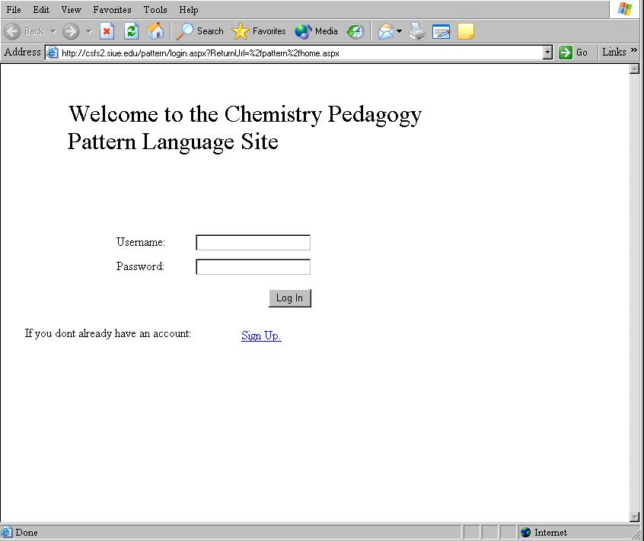
5.1 Prototype Screen Shot: Login

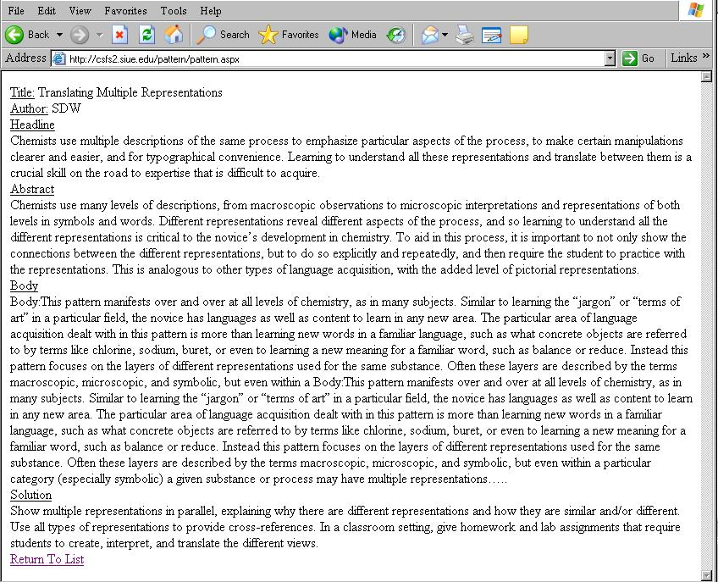
5.2 Prototype Screen Shot: Pattern Display
Section 6: Progress to Date

To develop this project the team had to utilize software tools that it was not familiar with. These tools are Microsoft C#, and ASP.NET. Prior to this project the team had little to no experience with these tools. However, throughout this semester the team members have been familiarizing themselves with these tools. Through research on the web and tinkering the team feels confident that it has gained enough knowledge to complete this project to the satisfaction of our client. All aspects of this project can be completed with knowledge and techniques already known by the team members, except for one. The patterns that will be stored by our system will need to be typed in rich text. None of the team members have ever done this before, so the technique for using ASP.NET to generate a rich text box had to be researched. To date the best example technique we have found was at Planet Source-Code.com. This example uses JavaScript to manipulate the document, but none of us have experience with JavaScript. We believe however, that we know enough about how it works to create our own rich text box custom for the client.

Section 7: List of Figures

Figure……………………………………………………………………………Page #

2.1 Use Case Model………………………………………………………..…………………….14

2.2 Class Diagram…………………………………………………………..……………………16

2.3 Add/Edit/Delete Pattern Screen…………………………………………..………………….24

2.4 Add/Edit/Delete User Screen……………………………………………………..………….25

2.5 Search Screen……………………………………………………………………..………….25

2.6 Add Comment Screen……………………………………………………………..…………26

3.1 Subsystem Diagram………………………………………………………………..………...28

3.2 Hardware/Software Mapping Diagram……………………………………………..………..30

3.3 Entity Relationship Diagram………………………………………………………..………..32

4.1 Fall 2003 Semester Gantt Chart……………………………………………………..……….34

4.2 Spring 2004 Semester Gantt Chart…………………………………………………..……….35

4.3 Waterfall with Subprojects Lifecycle Model…………………………………………..……..36

4.4 Organization Chart…..………………………………………………………………………..40

4.5 Estimated Manpower Requirements for Fall 2003………..………………………………….52

5.1 Prototype Screen Shot: Login………………………………………………………………....55

5.2 Prototype Screen Shot: Pattern………………………………………………………………..55

Section 8: Appendix

8.1 Team Members and Tasks completed

Daniel Harrington:

Compiled RAD, Hardware/Software mapping, Boundary Conditions, Compiled SDD, Organization Plan, Test Plan, Change Management Plan, Risk Management, Organization Chart, Client Contract, Prototype Coding, Compiled PowerPoint Presentation for Proj. Plan

Brian Bogovich:

Entity Relationship Diagram, Persistent Data Management, Subsystem Diagram, Documentation Plan, Training Plan, Resources and Deliverables Plan, Estimated Manpower Requirements Chart for Fall 2003, Prototype Coding, Webmaster

Chris Fleenor:

Use Cases, Subsystem Decomposition, Process Plan, Fall 2003 Semester Gantt Chart, Spring 2004 Semester Gantt Chart, Waterfall with Subprojects Lifecycle Model, Compiled Project Plan, Compiled and Authored Final Documentation

Andrew Miles:

Access Control and Security, Global Software Control, Proj. Plan Overview, Review and Reporting Plan, Installation and Operation Plan, Compiled PowerPoint Presentation for RAD, SDD, and Final Document

8.2 Example Code From Prototype

8.2.1 Overview
Attached are three files from our prototype.
Database.cs contains our data access code. It is pure C# code that uses ADO.net to access our Access database through ODBC. It has many functions that are used through the interface to access the database.
SignUp.aspx is the form that allows users to sign up for a new account on the system. It uses input validation controls to ensure the data follows the expected format. It was designed using Visual Studio’s form designer, and coded using C# ‘behind the page.’
ChangeUserInfo.aspx is the form that lets users change their information. It is a good example of how we keep track of who is logged in, and their information. It is also an ASP form.
8.2.1 Database.cs
using System;
using System.Collections;
using System.ComponentModel;
using System.Data;
using System.Data.Odbc;
using System.Web;
using System.Web.SessionState;

namespace pattern
{
public struct Pattern
{
public string PatternName;
public string Author;
public string Headline;
public string Abstract;
public string Body;
public string Solution;
};
public class UserInfo
{
public string username,password,fname,lname,email,affiliation;
public bool admin;
};
public class DatabaseAccess
{
private OdbcConnection dbConnection;
private OdbcCommand cmdUserPass;
private string strGetUserInfo, strAddUser;
//construct the DatabaseAccess class
public DatabaseAccess()
{

dbConnection=new OdbcConnection("Driver={Microsoft Access Driver (*.mdb)};Dsn=Pattern;Dbq=c:\\webdata\\db.mdb;Uid=Admin;Pwd=");

strGetUserInfo="SELECT User.username, User.password, User.fname, User.lname, User.email, User.affiliation, User.admin FROM [User];";

cmdUserPass = new OdbcCommand(strGetUserInfo);
cmdUserPass.Connection = dbConnection;
}
~DatabaseAccess()
{
dbConnection.Close();
}
//gets the full list of patterns in the database
public DataTable RetrievePatternList()
{
DataSet ds = new DataSet();
OdbcDataAdapter adapter = new OdbcDataAdapter("SELECT Pattern.patternName FROM [Pattern];", dbConnection);
adapter.Fill(ds, "Pattern");
return ds.Tables["Pattern"];
}
//get a user's info from the database
//if the username/password is not correct, null is returned
public UserInfo GetUser(string username, string password)
{
dbConnection.Open();
OdbcDataReader myReader=
cmdUserPass.ExecuteReader(CommandBehavior.CloseConnection);
while (myReader.Read())
{
if (username==myReader.GetString(0))
{
if (password==myReader.GetString(1))
{
UserInfo user = new UserInfo();
user.username=username;
user.password=password;
user.fname= myReader.GetString(2);
user.lname=myReader.GetString(3);
user.email=myReader.GetString(4);
user.affiliation=myReader.GetString(5);
user.admin=myReader.GetBoolean(6);
myReader.Close();
return user;
}
else
{
myReader.Close();
return null;
}
}
}
myReader.Close();
return null;
}
/*Add a user to the database*/
public bool AddUser(UserInfo info)
{
string sq="', '";
string insertUser="INSERT INTO User(username,password,fname,lname,email,affiliation,admin) VALUES ("
+"'"+info.username+sq+info.password+sq
+info.fname+sq+info.lname+sq+info.email
+sq+info.affiliation+"', No);";
dbConnection.Open();
OdbcCommand inscmd = new OdbcCommand(insertUser,dbConnection);
inscmd.CommandType=CommandType.Text;
try
{
inscmd.ExecuteNonQuery();
}
catch
{
dbConnection.Close();
return false;
}
dbConnection.Close();
return true;
}
/*remove a user from the database*/
public bool RemoveUser(string username)
{
OdbcCommand cmdRemove=new OdbcCommand("DELETE FROM User WHERE username='"+username+"'",dbConnection);
cmdRemove.Connection=dbConnection;
try
{
cmdRemove.ExecuteNonQuery();
}
catch
{
return false;
}
return true;
}
//update a user's information in the database
public bool UpdateUser(UserInfo info)
{
if (RemoveUser(info.username))
{
return AddUser(info);
}
return false;
}
//gets a pattern of the given name from the
//database
public Pattern RetrievePattern(string name)
{
dbConnection.Open();
Pattern pat = new Pattern();
string query = "SELECT * FROM Pattern WHERE (patternName = '"+name+"');";
OdbcCommand patternCmd = new OdbcCommand(query, dbConnection);
OdbcDataReader reader =
patternCmd.ExecuteReader(CommandBehavior.CloseConnection |
CommandBehavior.SingleRow);
while(reader.Read())
{
pat.PatternName = reader.GetString(0);
pat.Author = reader.GetString(1);
pat.Headline = reader.GetString(2);
pat.Abstract = reader.GetString(3);
pat.Body = reader.GetString(4);
pat.Solution = reader.GetString(5);
}
reader.Close();
return pat;
}
};
}
8.2.2 signup.aspx
<%@ Page language="c#" Codebehind="SignUp.aspx.cs" AutoEventWireup="false" Inherits="pattern.SignUp" %>
<!DOCTYPE HTML PUBLIC "-//W3C//DTD HTML 4.0 Transitional//EN" >
<HTML>
<HEAD>
<title>SignUp</title>
<meta name="vs_snapToGrid" content="True">
<meta name="GENERATOR" Content="Microsoft Visual Studio .NET 7.1">
<meta name="CODE_LANGUAGE" Content="C#">
<meta name="vs_defaultClientScript" content="JavaScript">
<meta name="vs_targetSchema" content="http://schemas.microsoft.com/intellisense/ie5">
</HEAD>
<body MS_POSITIONING="GridLayout">
<form id="Form1" method="post" runat="server">
<asp:Label id="Label3" style="Z-INDEX: 101; LEFT: 103px; POSITION: absolute; TOP: 56px" runat="server"
Font-Size="X-Large" Width="372px" Height="56px">Please enter your information</asp:Label>
<asp:RequiredFieldValidator id="RequiredFieldValidator4" style="Z-INDEX: 120; LEFT: 16px; POSITION: absolute; TOP: 320px"
runat="server" ErrorMessage="Required" ControlToValidate="txtUserName"></asp:RequiredFieldValidator>
<asp:RequiredFieldValidator id="RequiredFieldValidator3" style="Z-INDEX: 118; LEFT: 16px; POSITION: absolute; TOP: 152px"
runat="server" ErrorMessage="Required" ControlToValidate="txtFirstName"></asp:RequiredFieldValidator>
<asp:RequiredFieldValidator id="RequiredFieldValidator2" style="Z-INDEX: 117; LEFT: 16px; POSITION: absolute; TOP: 200px"
runat="server" ErrorMessage="Required" ControlToValidate="txtLastName"></asp:RequiredFieldValidator><INPUT id="htmlPass" runat="server" style="Z-INDEX: 113; LEFT: 224px; WIDTH: 152px; POSITION: absolute; TOP: 360px; HEIGHT: 22px"
tabIndex="1" type="password" size="20" name="htmlPass">
<asp:Label id="Label7" style="Z-INDEX: 112; LEFT: 120px; POSITION: absolute; TOP: 360px" runat="server"
Width="88px" Height="24px">Password:</asp:Label>
<asp:Label id="Label6" style="Z-INDEX: 111; LEFT: 120px; POSITION: absolute; TOP: 320px" runat="server"
Width="88px" Height="24px">Username:</asp:Label>
<asp:TextBox id="txtUserName" style="Z-INDEX: 110; LEFT: 224px; POSITION: absolute; TOP: 320px"
runat="server" Width="152px"></asp:TextBox>
<asp:Label id="Label4" style="Z-INDEX: 107; LEFT: 120px; POSITION: absolute; TOP: 240px" runat="server">E-Mail:</asp:Label>
<asp:TextBox id="txtFirstName" style="Z-INDEX: 102; LEFT: 224px; POSITION: absolute; TOP: 152px"
runat="server" Width="152px"></asp:TextBox>
<asp:TextBox id="txtLastName" style="Z-INDEX: 103; LEFT: 224px; POSITION: absolute; TOP: 200px"
runat="server" Width="152px"></asp:TextBox>
<asp:TextBox id="txtEmail" style="Z-INDEX: 104; LEFT: 224px; POSITION: absolute; TOP: 240px"
runat="server" Width="152px"></asp:TextBox>
<asp:Label id="Label1" style="Z-INDEX: 105; LEFT: 120px; POSITION: absolute; TOP: 152px" runat="server">First Name:</asp:Label>
<asp:Label id="Label2" style="Z-INDEX: 106; LEFT: 120px; POSITION: absolute; TOP: 200px" runat="server">Last Name:</asp:Label>
<asp:TextBox id="txtAffiliation" style="Z-INDEX: 108; LEFT: 224px; POSITION: absolute; TOP: 280px"
runat="server" Width="336px"></asp:TextBox>
<asp:Label id="Label5" style="Z-INDEX: 109; LEFT: 120px; POSITION: absolute; TOP: 280px" runat="server"
Width="88px" Height="24px">Affiliation:</asp:Label>
<asp:Button id="bnRegister" style="Z-INDEX: 114; LEFT: 120px; POSITION: absolute; TOP: 432px"
runat="server" Text="Register"></asp:Button>
<asp:RequiredFieldValidator id="RequiredFieldValidator1" style="Z-INDEX: 115; LEFT: 16px; POSITION: absolute; TOP: 280px"
runat="server" ErrorMessage="Required" ControlToValidate="txtAffiliation"></asp:RequiredFieldValidator>
<asp:RegularExpressionValidator id="RegularExpressionValidator1" style="Z-INDEX: 116; LEFT: 392px; POSITION: absolute; TOP: 240px"
runat="server" ErrorMessage="Invalid Email Address" ValidationExpression="\w+([-+.]\w+)*@\w+([-.]\w+)*\.\w+([-.]\w+)*"
ControlToValidate="txtEmail"></asp:RegularExpressionValidator>
<asp:Label id="txtUsernameError" style="Z-INDEX: 119; LEFT: 392px; POSITION: absolute; TOP: 320px"
runat="server" ForeColor="Red" Visible="False">Username Already Taken</asp:Label>
<asp:RegularExpressionValidator id="RegularExpressionValidator2" style="Z-INDEX: 121; LEFT: 392px; POSITION: absolute; TOP: 360px"
runat="server" Height="20px" Width="255px" ControlToValidate="htmlPass" ErrorMessage="Password must be 5 to 15 characters"
ValidationExpression="\w{5,15}"></asp:RegularExpressionValidator>
</form>
</body>
</HTML>

SignUp.aspx.cs

using System;
using System.Collections;
using System.ComponentModel;
using System.Data;
using System.Drawing;
using System.Web;
using System.Web.Security;
using System.Web.SessionState;
using System.Web.UI;
using System.Web.UI.WebControls;
using System.Web.UI.HtmlControls;

namespace pattern
{
/// <summary>
/// Summary description for SignUp.
/// </summary>
public class SignUp : System.Web.UI.Page
{
protected System.Web.UI.WebControls.Label Label1;
protected System.Web.UI.WebControls.Label Label2;
protected System.Web.UI.WebControls.Label Label4;
protected System.Web.UI.WebControls.Label Label5;
protected System.Web.UI.WebControls.Label Label6;
protected System.Web.UI.WebControls.Label Label7;
protected System.Web.UI.HtmlControls.HtmlInputText htmlPass;
protected System.Web.UI.WebControls.TextBox txtUserName;
protected System.Web.UI.WebControls.TextBox txtFirstName;
protected System.Web.UI.WebControls.TextBox txtLastName;
protected System.Web.UI.WebControls.TextBox txtEmail;
protected System.Web.UI.WebControls.TextBox txtAffiliation;
protected System.Web.UI.WebControls.Button bnRegister;
protected System.Web.UI.WebControls.RequiredFieldValidator RequiredFieldValidator1;
protected System.Web.UI.WebControls.RegularExpressionValidator RegularExpressionValidator1;
protected System.Web.UI.WebControls.RequiredFieldValidator RequiredFieldValidator2;
protected System.Web.UI.WebControls.RequiredFieldValidator RequiredFieldValidator3;
protected System.Web.UI.WebControls.Label txtUsernameError;
protected System.Web.UI.WebControls.RequiredFieldValidator RequiredFieldValidator4;
protected System.Web.UI.WebControls.RegularExpressionValidator RegularExpressionValidator2;
protected System.Web.UI.WebControls.Label Label3;

private void Page_Load(object sender, System.EventArgs e)
{

// Put user code to initialize the page here
}

#region Web Form Designer generated code
override protected void OnInit(EventArgs e)
{
//
// CODEGEN: This call is required by the ASP.NET Web Form Designer.
//
InitializeComponent();
base.OnInit(e);
}

/// <summary>
/// Required method for Designer support - do not modify
/// the contents of this method with the code editor.
/// </summary>
private void InitializeComponent()
{
this.bnRegister.Click += new System.EventHandler(this.bnRegister_Click);
this.Load += new System.EventHandler(this.Page_Load);

}
#endregion
private void bnRegister_Click(object sender, System.EventArgs e)
{
DatabaseAccess dba=(DatabaseAccess)Page.Application["DataAccess"];
UserInfo ui=new UserInfo();
ui.admin=false;
ui.affiliation=txtAffiliation.Text;
ui.email=txtEmail.Text;
ui.fname=txtFirstName.Text;
ui.lname=txtLastName.Text;
ui.password=htmlPass.Value;
ui.username=txtUserName.Text;

if (dba.AddUser(ui))
{
this.Session.Add("UserInfo",ui);
this.Response.Redirect("../SignUpSuccess.aspx");
}
else
{
txtUsernameError.Visible=true;
}
}
}
}
8.2.3 ChangeUserInfo.aspx
<%@ Page language="c#" Codebehind="ChangeUserInfo.aspx.cs" AutoEventWireup="false" Inherits="pattern.ChangeUserInfo" %>
<!DOCTYPE HTML PUBLIC "-//W3C//DTD HTML 4.0 Transitional//EN" >
<HTML>
<HEAD>
<title>ChangeUserInfo</title>
<meta name="GENERATOR" Content="Microsoft Visual Studio .NET 7.1">
<meta name="CODE_LANGUAGE" Content="C#">
<meta name="vs_defaultClientScript" content="JavaScript">
<meta name="vs_targetSchema" content="http://schemas.microsoft.com/intellisense/ie5">
</HEAD>
<body MS_POSITIONING="GridLayout">
<form id="Form1" method="post" runat="server">
<asp:Label id="Label3" style="Z-INDEX: 117; LEFT: 23px; POSITION: absolute; TOP: 21px" runat="server"
Font-Size="X-Large" Width="543px" Height="56px">Please update your information</asp:Label>
<asp:RegularExpressionValidator id="RegularExpressionValidator2" style="Z-INDEX: 121; LEFT: 136px; POSITION: absolute; TOP: 399px"
runat="server" Height="20px" Width="255px" ControlToValidate="htmlPass" ErrorMessage="Password must be 5 to 15 characters"
ValidationExpression="\w{5,15}"></asp:RegularExpressionValidator>
<asp:RequiredFieldValidator id="RequiredFieldValidator4" style="Z-INDEX: 119; LEFT: 33px; POSITION: absolute; TOP: 369px"
runat="server" ControlToValidate="htmlPass" ErrorMessage="Required"></asp:RequiredFieldValidator>
<asp:RequiredFieldValidator id="RequiredFieldValidator3" style="Z-INDEX: 116; LEFT: 31px; POSITION: absolute; TOP: 165px"
runat="server" ErrorMessage="Required" ControlToValidate="txtFirstName"></asp:RequiredFieldValidator>
<asp:RequiredFieldValidator id="RequiredFieldValidator2" style="Z-INDEX: 115; LEFT: 31px; POSITION: absolute; TOP: 213px"
runat="server" ErrorMessage="Required" ControlToValidate="txtLastName"></asp:RequiredFieldValidator><INPUT id="htmlPass" style="Z-INDEX: 110; LEFT: 239px; WIDTH: 152px; POSITION: absolute; TOP: 373px; HEIGHT: 22px"
tabIndex="1" type="password" size="20" name="htmlPass" runat="server">
<asp:Label id="Label7" style="Z-INDEX: 109; LEFT: 135px; POSITION: absolute; TOP: 373px" runat="server"
Width="88px" Height="24px">Password:</asp:Label>
<asp:Label id="Label6" style="Z-INDEX: 108; LEFT: 135px; POSITION: absolute; TOP: 333px" runat="server"
Width="88px" Height="24px">Username:</asp:Label>
<asp:Label id="Label4" style="Z-INDEX: 105; LEFT: 135px; POSITION: absolute; TOP: 253px" runat="server">E-Mail:</asp:Label>
<asp:TextBox id="txtFirstName" style="Z-INDEX: 100; LEFT: 239px; POSITION: absolute; TOP: 165px"
runat="server" Width="152px"></asp:TextBox>
<asp:TextBox id="txtLastName" style="Z-INDEX: 101; LEFT: 239px; POSITION: absolute; TOP: 213px"
runat="server" Width="152px"></asp:TextBox>
<asp:TextBox id="txtEmail" style="Z-INDEX: 102; LEFT: 239px; POSITION: absolute; TOP: 253px"
runat="server" Width="152px"></asp:TextBox>
<asp:Label id="Label1" style="Z-INDEX: 103; LEFT: 135px; POSITION: absolute; TOP: 165px" runat="server">First Name:</asp:Label>
<asp:Label id="Label2" style="Z-INDEX: 104; LEFT: 135px; POSITION: absolute; TOP: 213px" runat="server">Last Name:</asp:Label>
<asp:TextBox id="txtAffiliation" style="Z-INDEX: 106; LEFT: 239px; POSITION: absolute; TOP: 293px"
runat="server" Width="336px"></asp:TextBox>
<asp:Label id="Label5" style="Z-INDEX: 107; LEFT: 135px; POSITION: absolute; TOP: 293px" runat="server"
Width="88px" Height="24px">Affiliation:</asp:Label>
<asp:Button id="bnRegister" style="Z-INDEX: 111; LEFT: 135px; POSITION: absolute; TOP: 445px"
runat="server" Text="Update"></asp:Button>
<asp:RequiredFieldValidator id="RequiredFieldValidator1" style="Z-INDEX: 112; LEFT: 31px; POSITION: absolute; TOP: 293px"
runat="server" ErrorMessage="Required" ControlToValidate="txtAffiliation"></asp:RequiredFieldValidator>
<asp:RegularExpressionValidator id="RegularExpressionValidator1" style="Z-INDEX: 114; LEFT: 407px; POSITION: absolute; TOP: 253px"
runat="server" ErrorMessage="Invalid Email Address" ControlToValidate="txtEmail" ValidationExpression="\w+([-+.]\w+)*@\w+([-.]\w+)*\.\w+([-.]\w+)*"></asp:RegularExpressionValidator>
<asp:Label id="lblUserName" style="Z-INDEX: 118; LEFT: 242px; POSITION: absolute; TOP: 333px"
runat="server"></asp:Label>
</form>
</body>
</HTML>

ChangeUserInfo.aspx.cs
using System;
using System.Collections;
using System.ComponentModel;
using System.Data;
using System.Drawing;
using System.Web;
using System.Web.SessionState;
using System.Web.UI;
using System.Web.UI.WebControls;
using System.Web.UI.HtmlControls;

namespace pattern
{
/// <summary>
/// Summary description for ChangeUserInfo.
/// </summary>
public class ChangeUserInfo : System.Web.UI.Page
{
protected System.Web.UI.WebControls.RegularExpressionValidator RegularExpressionValidator1;
protected System.Web.UI.WebControls.RequiredFieldValidator RequiredFieldValidator1;
protected System.Web.UI.WebControls.Button bnRegister;
protected System.Web.UI.WebControls.Label Label5;
protected System.Web.UI.WebControls.TextBox txtAffiliation;
protected System.Web.UI.WebControls.Label Label2;
protected System.Web.UI.WebControls.Label Label1;
protected System.Web.UI.WebControls.TextBox txtEmail;
protected System.Web.UI.WebControls.TextBox txtLastName;
protected System.Web.UI.WebControls.TextBox txtFirstName;
protected System.Web.UI.WebControls.Label Label4;
protected System.Web.UI.WebControls.Label Label6;
protected System.Web.UI.WebControls.Label Label7;
protected System.Web.UI.WebControls.RequiredFieldValidator RequiredFieldValidator2;
protected System.Web.UI.WebControls.RequiredFieldValidator RequiredFieldValidator3;
protected System.Web.UI.WebControls.Label Label3;
protected System.Web.UI.WebControls.Label lblUserName;
protected System.Web.UI.WebControls.RequiredFieldValidator RequiredFieldValidator4;
protected System.Web.UI.WebControls.RegularExpressionValidator RegularExpressionValidator2;
protected System.Web.UI.HtmlControls.HtmlInputText htmlPass;

private void Page_Load(object sender, System.EventArgs e)
{
if (!Page.IsPostBack)
{
UserInfo ui = (UserInfo)Session["UserInfo"];
lblUserName.Text=ui.username;
txtFirstName.Text=ui.fname;
txtLastName.Text=ui.lname;
txtAffiliation.Text=ui.affiliation;
txtEmail.Text=ui.email;
}
}

#region Web Form Designer generated code
override protected void OnInit(EventArgs e)
{
//
// CODEGEN: This call is required by the ASP.NET Web Form Designer.
//
InitializeComponent();
base.OnInit(e);
}

/// <summary>
/// Required method for Designer support - do not modify
/// the contents of this method with the code editor.
/// </summary>
private void InitializeComponent()
{
this.bnRegister.Click += new System.EventHandler(this.bnRegister_Click);
this.Load += new System.EventHandler(this.Page_Load);

}
#endregion

private void bnRegister_Click(object sender, System.EventArgs e)
{
UserInfo ui=(UserInfo)Session["UserInfo"];
ui.affiliation=txtAffiliation.Text;
ui.fname=txtFirstName.Text;
ui.lname=txtLastName.Text;
ui.email=txtEmail.Text;
ui.password=htmlPass.Value;
DatabaseAccess da=(DatabaseAccess)this.Application["DataAccess"];
da.UpdateUser(ui);
Response.Redirect("Home.aspx");
}
}
}

